MD070 Application Extension Technical Design *Form*

Credit Limit Management System

Author: Amit Rajput

Creation Date: Jun 11, 2024

Last Updated: Jun 11, 2024

Document Ref:

Version: V1.0

**Approvals:**

|  |  |
| --- | --- |
| Domain Manager | Mr. Ajay Rambal |
| Customer Domain manager | Mr. Mayank Verma |

### Document Control

**Change Record**

1

| Date | Author | Version | Change Reference |
| --- | --- | --- | --- |
| 28 |  |  |  |
| 11-Jun-2024 | Vikrant Kumar | 1.0 | Initial Release |
| 11-Jun-2024 | Rishab Chauhan | 1.0 | Initial Release |
| 11-Jun-2024 | Ankit Srivastava | 1.0 | Initial Release |
|  |  |  |  |
|  |  |  |  |
|  |  |  |  |
|  |  |  |  |
|  |  |  |  |

**Reviewers**

| Name | Position |
| --- | --- |
|  |  |
| Amit Rajput | Project Manager |
|  |  |
|  |  |
|  |  |
|  |  |
|  |  |
|  |  |
|  |  |
|  |  |
|  |  |
|  |  |
|  |  |
|  |  |
|  |  |

Contents

Document Control 2

**Business Process Overview (As per HLD)** 4

System Overview 4

Technology 4

Login System 5

Lookup Master 6

Notes Master 9

Financial Statements 11

1. F.Y Status Master 11

2. Financial Year Attachment Master 13

Sales Upload 17

Insurance Upload 21

OD Upload 25

Collection Upload 29

Credit Limit Request 34

1. Credit Limit Request 34

2. Bulk Credit Limit Request 35

Credit Limit List 40

1. Request Approval 40

2. Credit Limit List 40

3. Masters Updated History 40

Backend Process 45

1. Jobs (NEXTDNET) 45

## **Business Process Overview (As per HLD)**

* + Develop complete process for manage Customers of Credit Limits on Header Code business with LG.
  + Develop DB process for manage all Requests/Approval/View Details/PDF download.
  + API Development.
  + Reports.

### System Overview

**Masters**

1. Lookup Master (Accessible by Admin).
2. Notes Master (Accessible by Admin).
3. Financial Statement (Accessible by Admin)
   1. F.Y Status Master
   2. Financial Year Attachment Master
4. Sales Upload (Accessible by Admin)
5. Insurance Upload (Accessible by Admin)
6. OD Upload (Accessible by Admin)
7. Collection Upload (Accessible by Admin)

**Credit Limit Request & List**

1. New Credit Limit Request register by Branch.
2. All registered credit limit request view by Branch & Admin.
3. Credit Limit Request Approval by only Admin (HO).
4. Bulk Request Upload features Enable/ Disable as per needs.
5. Auto Email of Credit Limit Request or Credit Limit of Status updates, PDF auto email to send concern person by JOBS.
6. Credit Limit Request/Pending/Closed of all summery auto email send for reminder by JOBS.

### Technology

* Frontend : Angular (14)
* Backend : DotNet Core (3.1)
* Database : Oracle

### Login System

After DealerNetPlus new Login=>you found “Branch Accounts Operation” link for access the “**Insurance Credit Limit**” module. After click on “Insurance Credit Limit” you redirect to another website for do all jobs related to this module/ process.

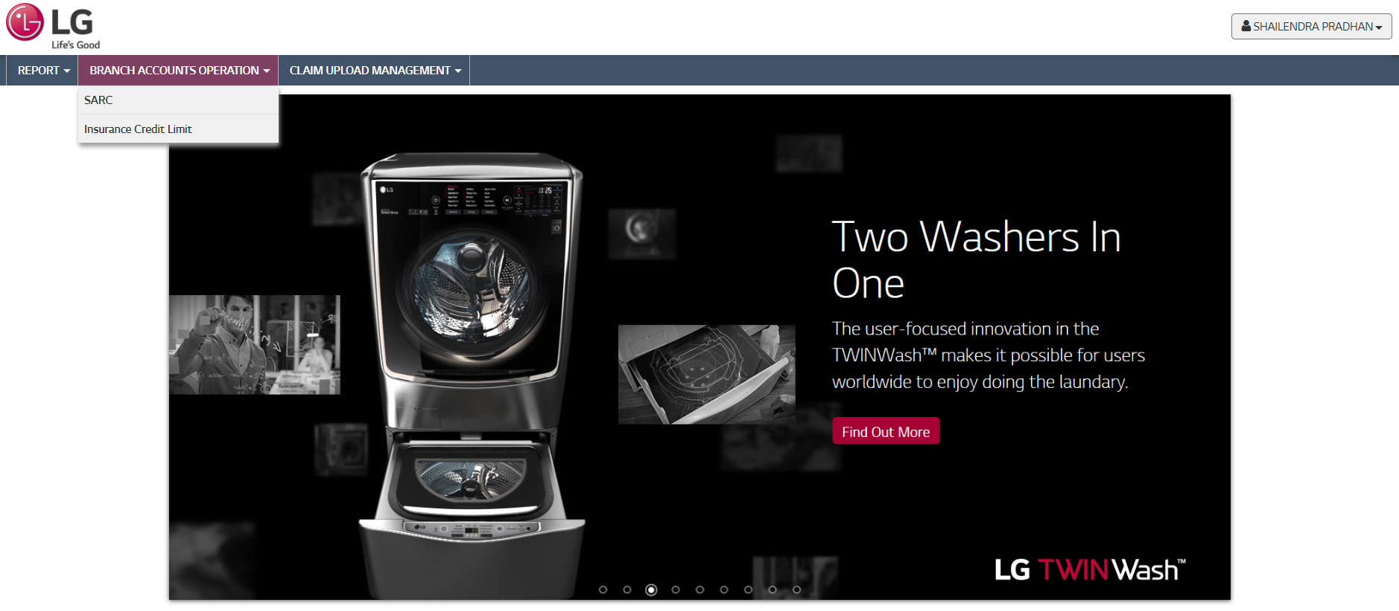

**LOGIN (via SSO) Insurance Credit Limit**

|  |  |  |  |
| --- | --- | --- | --- |
| **Sno.** | **API Name** | **Action** | **Remarks** |
| **1.** | Account/Authenticate | Page Load | Check user details & validate for system login. And, also **Bearer Token** generate for system process. |

**Authenticate Portal URL:** https://nextlgdealernet.com/NextLGDealerNet/auth?param1=65AF72C8B5B9136C8788C2C09061FB70&param2=1718600264195

**Home (Landing Page) ~ “https://nextlgdealernet.com/NextLGDealerNet/newui/home” Website**

Home page (Landing page) of the website. Here Menu bind according to Users give rights.



**Used API (Bind menus)**

|  |  |  |  |
| --- | --- | --- | --- |
| **SNo.** | **API Name** | **Action** | **Remarks** |
| **1.** | api/MenuMaster/ReadTaskMapping | Page Load | All Menu bind which is assign to Login User |

### Lookup Master

Lookup master data setup related to “Credit Limit” process. Here multiple Lookup master data setup like: Credit Limit Corporate Email, Insurance Company. Export all lookup master data as per required.

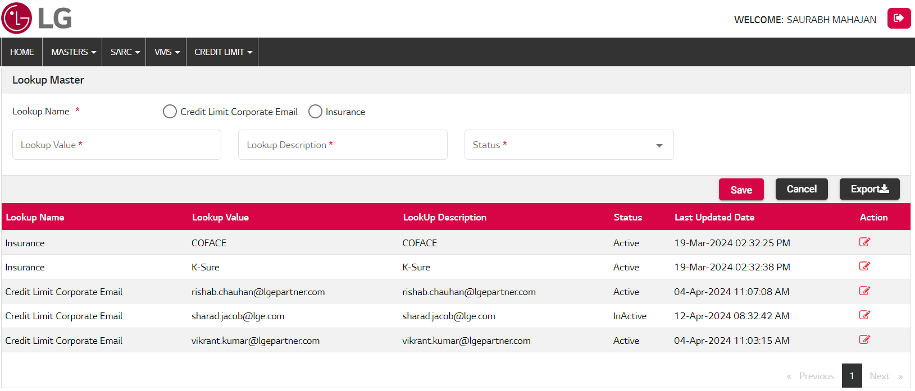

|  |  |  |
| --- | --- | --- |
| BACKEND (DNET09) | | |
| Package Name | **Object Name** | **Remarks** |
| DNET09_LOOKUP_MASTER_PKG | LOOKUP_DETAILS_INSERT_UPD_PROC | Lookup Details Insert |
| DNET09_LOOKUP_MASTER_PKG | LOOKUP_DETAILS_READ_PROC | Lookup Details Read |
| DNET09_LOOKUP_MASTER_PKG | LOOKUP_TYPES_READ_PROC | Lookup Header Details Read |

|  |  |  |  |
| --- | --- | --- | --- |
|  |  | API | |
| SNo. | **Action** | **API Name** | **Remarks** |
| 1. | Bind Radio buttons | LookupMaster/ReadLookupTypes | Fetch all lookup types (Lookup Name) |
| 2. | Edit Button | LookupMaster/SaveLookup | Update status detail. |
| 3. | Save Button | LookupMaster/SaveLookup | All Inputs are required & Save details. |
| 4. | Cancel Button |  | Rest the input field |
| 5. | Grid View | LookupMaster/ReadLookup | Shows the list of Lookups, with edit option on Action column. |
| 6. | Export | LookupMaster/ReadLookup | Export excel report |

| Model Name | | CREDIT LIMIT | | | Table Owner | |  | | |
| --- | --- | --- | --- | --- | --- | --- | --- | --- | --- |
| Table Name | | DNET_LOOKUP_HEADERS | | | Entity Name | |  | | |
| Table Description | | LOOKUP HEADER Table | | | | | | | |
| Column Name | Key | | Data Type | Length | | Nullable | | Attribute Name | Default Value |
| LOOKUP_ID |  | | NUMBER |  | |  | |  |  |
| LOOKUP_NAME |  | | VARCHAR2(50) |  | | Y | |  |  |
| LOOKUP_INFO |  | | VARCHAR2(250) |  | | Y | |  |  |
| AFFILIATE_CODE |  | | VARCHAR2(20) |  | | Y | |  |  |
| CREATED_BY |  | | VARCHAR2(50) |  | | Y | |  | ‘ADMIN’ |
| CREATION_DATE |  | | DATE |  | | Y | |  | SYSDATE |
| LAST_UPDATED_BY |  | | VARCHAR2(50) |  | | Y | |  | ‘ADMIN’ |
| LAST_UPDATE_DATE |  | | DATE |  | | Y | |  | SYSDATE |
| ATTRIBUTE1 |  | | VARCHAR2(250) |  | | Y | |  |  |
| ATTRIBUTE2 |  | | VARCHAR2(250) |  | | Y | |  |  |
| ATTRIBUTE3 |  | | VARCHAR2(250) |  | | Y | |  |  |
| ATTRIBUTE4 |  | | VARCHAR2(250) |  | | Y | |  |  |
| ATTRIBUTE5 |  | | VARCHAR2(250) |  | | Y | |  |  |

| Model Name | | CREDIT LIMIT | | | Table Owner | |  | |
| --- | --- | --- | --- | --- | --- | --- | --- | --- |
| Table Name | | DNET_LOOKUP_DETAILS | | | Entity Name | |  | |
| Table Description | | LOOKUP HEADER Details Table | | | | | | |
| Column Name | Key | | Data Type | Length | | Nullable | Attribute Name | Default Value |
| ID |  | | NUMBER |  | |  |  |  |
| LOOKUP_ID |  | | NUMBER |  | |  |  |  |
| LOOKUP_VAL |  | | VARCHAR2(250) |  | |  |  |  |
| LOOKUP_DESC |  | | VARCHAR2(250) |  | | Y |  |  |
| USE_FLAG |  | | VARCHAR2(1) |  | | Y |  |  |
| DISP_SEQ |  | | NUMBER |  | | Y |  |  |
| CREATED_BY |  | | VARCHAR2(50) |  | | Y |  | ‘ADMIN’ |
| CREATION_DATE |  | | DATE |  | | Y |  | SYSDATE |
| LAST_UPDATED_BY |  | | VARCHAR2(50) |  | | Y |  | 'ADMIN' |
| LAST_UPDATE_DATE |  | | DATE |  | | Y |  | SYSDATE |
| ATTRIBUTE1 |  | | VARCHAR2(250) |  | | Y |  |  |
| ATTRIBUTE2 |  | | VARCHAR2(250) |  | | Y |  |  |
| ATTRIBUTE3 |  | | VARCHAR2(250) |  | | Y |  |  |
| ATTRIBUTE4 |  | | VARCHAR2(250) |  | | Y |  |  |
| ATTRIBUTE5 |  | | VARCHAR2(250) |  | | Y |  |  |
| ATTRIBUTE6 |  | | VARCHAR2(250) |  | | Y |  |  |
| ATTRIBUTE7 |  | | DATE |  | | Y |  |  |
| ATTRIBUTE8 |  | | DATE |  | | Y |  |  |
| ATTRIBUTE9 |  | | DATE |  | | Y |  |  |
| ATTRIBUTE10 |  | | DATE |  | | Y |  |  |
| ATTRIBUTE11 |  | | NUMBER |  | | Y |  |  |
| ATTRIBUTE12 |  | | NUMBER |  | | Y |  |  |
| ATTRIBUTE13 |  | | NUMBER |  | | Y |  |  |
| ATTRIBUTE14 |  | | NUMBER |  | | Y |  |  |

### Notes Master

New Notes manage here and show all notes in grid view for view & change notes details.

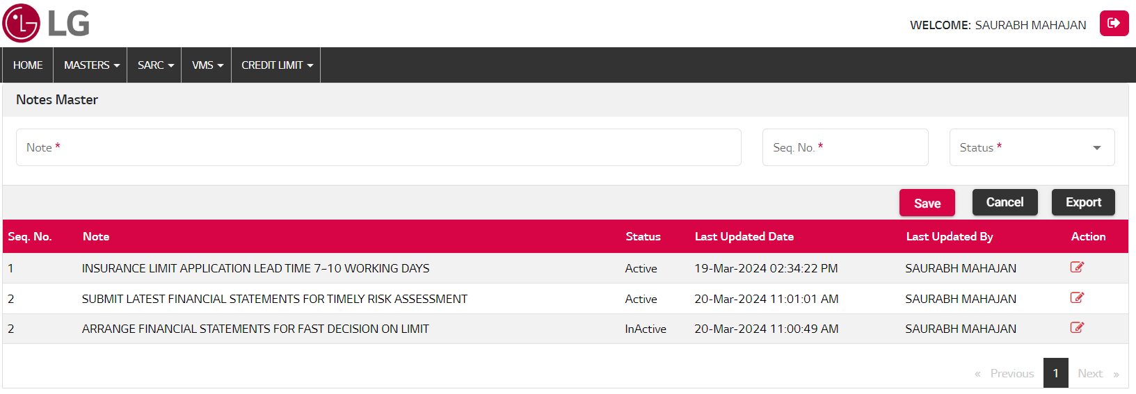

|  |  |  |
| --- | --- | --- |
| BACKEND (NEXTDNET) | | |
| Package Name | **Object Name** | **Remarks** |
| CL_NOTES_MASTER_PKG | CL_NOTES_INSERT_PROC | Notes Details Insert/ Update |
| CL_NOTES_MASTER_PKG | CL_NOTES_READ_PROC | Notes Details Read |

|  |  |  |  |
| --- | --- | --- | --- |
|  |  | API | |
| SNo. | **Action** | **API Name** | **Remarks** |
| 1. | Save Button | api/UtilitiesARCreditLimit/NoteSave | All Inputs are required & Save details. |
| 2. | Edit Button | api/UtilitiesARCreditLimit/NoteSave | Update note detail. |
| 3. | Cancel Button |  | Rest the input field |
| 4. | Grid View | api/UtilitiesARCreditLimit/ReadNotes | Shows the list of notes. |
| 5. | Export | api/UtilitiesARCreditLimit/ReadNotes | Export excel report |

| Model Name | | CREDIT LIMIT SYSTEM | | | Table Owner | |  | | |
| --- | --- | --- | --- | --- | --- | --- | --- | --- | --- |
| Table Name | | CL_NOTES_MASTER_TB | | | Entity Name | |  | | |
| Table Description | | Notes Table | | | | | | | |
| Column Name | Key | | Data Type | Length | | Nullable | | Attribute Name | Default Value |
| ID |  | | NUMBER |  | |  | |  |  |
| NOTE |  | | VARCHAR2(2500) |  | |  | |  |  |
| STATUS |  | | VARCHAR2(10) |  | |  | |  |  |
| CREATED_BY |  | | VARCHAR2(250) |  | | Y | |  |  |
| CREATION_DATE |  | | DATE |  | | Y | |  | SYSDATE |
| LAST_UPDATED_BY |  | | VARCHAR2(250) |  | | Y | |  |  |
| LAST_UPDATED_DATE |  | | DATE |  | | Y | |  | SYSDATE |
| ATTRIBUTE1 |  | | VARCHAR2(500) |  | | Y | |  |  |
| ATTRIBUTE2 |  | | VARCHAR2(500) |  | | Y | |  |  |
| ATTRIBUTE3 |  | | VARCHAR2(500) |  | | Y | |  |  |
| ATTRIBUTE4 |  | | VARCHAR2(500) |  | | Y | |  |  |
| ATTRIBUTE5 |  | | VARCHAR2(500) |  | | Y | |  |  |
| ATTRIBUTE6 |  | | NUMBER |  | | Y | |  |  |
| ATTRIBUTE7 |  | | NUMBER |  | | Y | |  |  |
| ATTRIBUTE8 |  | | NUMBER |  | | Y | |  |  |
| ATTRIBUTE9 |  | | NUMBER |  | | Y | |  |  |
| ATTRIBUTE10 |  | | DATE |  | | Y | |  |  |
| ATTRIBUTE11 |  | | DATE |  | | Y | |  |  |
| ORDER_NO |  | | NUMBER |  | | Y | |  |  |

### Financial Statements

### F.Y Status Master

Financial Year Status master manage and show all status in grid view. We can also update the details respective status.

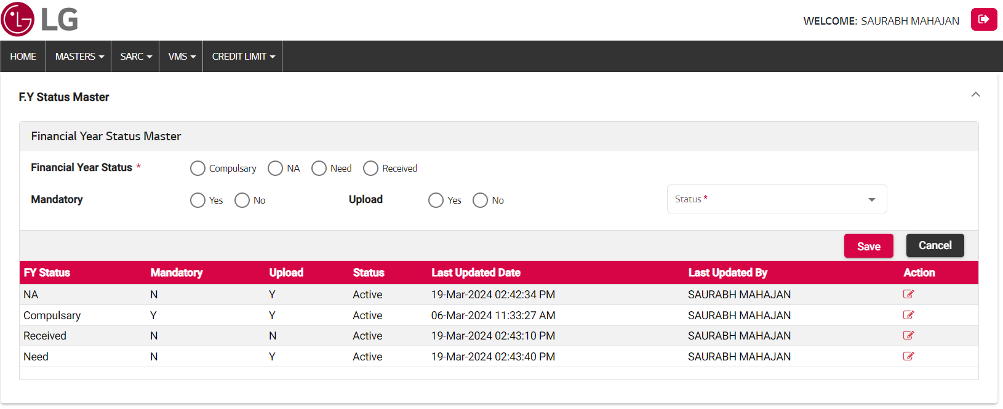

|  |  |  |
| --- | --- | --- |
| BACKEND (DNET09 & NEXTDNET) | | |
| Package Name | **Object Name** | **Remarks** |
| DNET09_LOOKUP_MASTER_PKG | LOOKUP_TYPES_READ_PROC | Financial Year Status Details Read |
| CL_FINANCIAL_YEAR_PKG | CL_FY_STATUS_INS_PROC | F.Y Status Insert/Update |
| CL_FINANCIAL_YEAR_PKG | CL_FY_STATUS_READ_PROC | F.Y Status Read |

|  |  |  |  |
| --- | --- | --- | --- |
|  |  | API | |
| SNo. | **Action** | **API Name** | **Remarks** |
| 1. | Radio button bind | api/LookupMaster/ReadLookup | Read & Bind Financial Year Status |
| 2. | Save Button | api/UtilitiesARCreditLimit/FYStatusSave | Select required input & Save details. |
| 3. | Edit Button | api/UtilitiesARCreditLimit/FYStatusSave | Update F.Y status master detail. |
| 4. | Cancel Button |  | Rest the input field |
| 5. | Grid View | api/UtilitiesARCreditLimit/FYStatusRead | Shows the list of F.Y status master |

| Model Name | CREDIT LIMIT SYSTEM | | | | Table Owner | |  | | |
| --- | --- | --- | --- | --- | --- | --- | --- | --- | --- |
| Table Name | CL_FINANCIAL_YEAR_STATUS_MST | | | | Entity Name | |  | | |
| Table Description | Financial Year Status Table | | | | | | | | |
| Column Name | | Key | Data Type | Length | | Nullable | | Attribute Name | Default Value |
| ID | |  | NUMBER |  | | Y | |  |  |
| FINANCIAL_YEAR_STATUS | |  | VARCHAR2(250) |  | | Y | |  |  |
| MANDATORY | |  | VARCHAR2(50) |  | | Y | |  |  |
| UPLOAD | |  | VARCHAR2(50) |  | | Y | |  |  |
| STATUS | |  | VARCHAR2(50) |  | | Y | |  |  |
| CREATED_BY | |  | VARCHAR2(250) |  | | Y | |  |  |
| CREATION_DATE | |  | DATE |  | | Y | |  | SYSDATE |
| LAST_UPDATED_BY | |  | VARCHAR2(250) |  | | Y | |  |  |
| LAST_UPDATED_DATE | |  | DATE |  | | Y | |  | SYSDATE |
| ATTRIBUTE1 | |  | VARCHAR2(500) |  | | Y | |  |  |
| ATTRIBUTE2 | |  | VARCHAR2(500) |  | | Y | |  |  |
| ATTRIBUTE3 | |  | VARCHAR2(500) |  | | Y | |  |  |
| ATTRIBUTE4 | |  | VARCHAR2(500) |  | | Y | |  |  |
| ATTRIBUTE5 | |  | VARCHAR2(500) |  | | Y | |  |  |
| ATTRIBUTE6 | |  | NUMBER |  | | Y | |  |  |
| ATTRIBUTE7 | |  | NUMBER |  | | Y | |  |  |
| ATTRIBUTE8 | |  | NUMBER |  | | Y | |  |  |
| ATTRIBUTE9 | |  | NUMBER |  | | Y | |  |  |
| ATTRIBUTE10 | |  | DATE |  | | Y | |  |  |
| ATTRIBUTE11 | |  | DATE |  | | Y | |  |  |
| ATTRIBUTE12 | |  | DATE |  | | Y | |  |  |

### Financial Year Attachment Master

Financial Year Attachment Master Process:-

* 1. Download template excel file
  2. Fill the data in template format with Header Code & Financial Year wise.
  3. Upload the same file with UPLOAD button.
  4. If any issues occurred in data while uploading show the error list and rectify the issues. After all issues resolved template file data uploaded successfully.
  5. Show all uploaded file List in Grid view (History, Current) and download the same uploaded file.
  6. Financial Year Attachment List data show. Search here with Header Code or Financial Year wise.

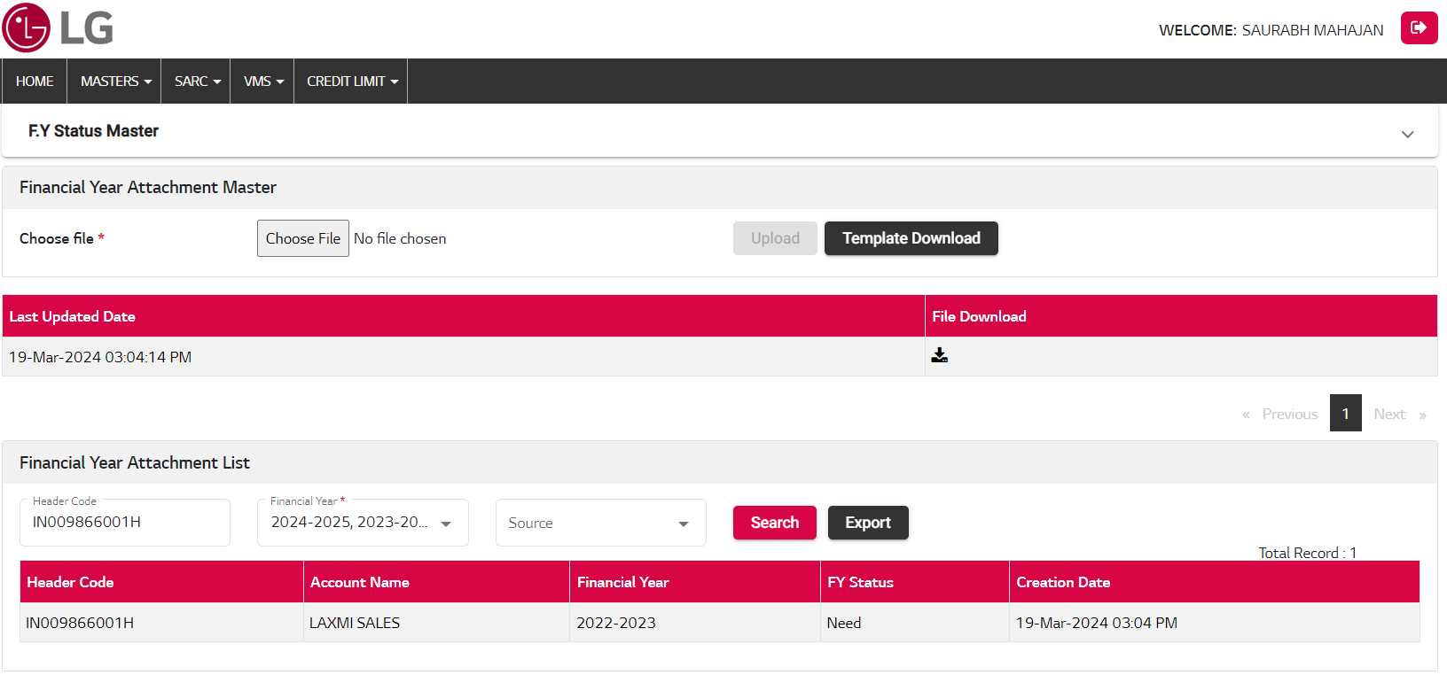

|  |  |  |
| --- | --- | --- |
| BACKEND (NEXTDNET) | | |
| Package Name | **Object Name** | **Remarks** |
| CL_FINANCIAL_YEAR_PKG | FY_ATTACHMENT_TEMP_INSERT_PROC | Financial Year Attachment Temp Insert |
| CL_FINANCIAL_YEAR_PKG | FY_ATTACHMENT_TEMP_VALID_PROC | Financial Year Attachment Temp Validate |
| CL_FINANCIAL_YEAR_PKG | FY_ATTACHMENT_MAIN_INSERT_PROC | Financial Year Attachment Main Insert |
| CL_FINANCIAL_YEAR_PKG | FY_ATTACHMENT_READ_PROC | Financial Year Attachment Read |

|  |  |  |  |
| --- | --- | --- | --- |
|  |  | API | |
| SNo. | **Action** | **API Name** | **Remarks** |
| 1. | Template Download | N/A | Excel format download with Header Code & Last two financial years dynamic. |
| 2. | Upload Button | api/UtilitiesARCreditLimit/FinancialYearAttachmentUpload | Upload template data for Financial Year Attachment. |
| 3. | Grid View (Upload Logs) | api/UtilitiesARCreditLimit/UploadFilesLogRead?ProcessType=FY_ATTACHMENT_UPLOAD | Show all uploaded file logs. |
| 4. | File Download | api/UtilitiesARCreditLimit/FileDownload | Upload Log file download |
| 5. | Grid View (FY Attachment List) | api/UtilitiesARCreditLimit/FinancialYearAttachmentRead | Shows the list of Financial Year Attachments, Search according to parameters. (History, Current data) |
| 6. | Export | api/UtilitiesARCreditLimit/FinancialYearAttachmentRead | Export excel report |

| Model Name | CREDIT LIMIT SYSTEM | | | | Table Owner | |  | |
| --- | --- | --- | --- | --- | --- | --- | --- | --- |
| Table Name | CL_FIN_YEAR_ATTACHMNT_TMP_TB | | | | Entity Name | |  | |
| Table Description | Financial Year Attachment Temp Table | | | | | | | |
| Column Name | | Key | Data Type | Length | Nullable | Attribute Name | | Default Value |
| HEADER_CODE | |  | VARCHAR2(100) |  | Y |  | |  |
| FINANCIAL_YEAR | |  | VARCHAR2(250) |  | Y |  | |  |
| FINANCIAL_YEAR_STATUS | |  | VARCHAR2(250) |  | Y |  | |  |
| STATUS | |  | VARCHAR2(50) |  | Y |  | |  |
| REMARKS | |  | VARCHAR2(500) |  | Y |  | |  |
| ROW_NUMBER | |  | NUMBER |  | Y |  | |  |
| REQ_ID | |  | NUMBER |  | Y |  | |  |
| CREATED_BY | |  | VARCHAR2(250) |  | Y |  | |  |
| CREATION_DATE | |  | DATE |  | Y |  | | SYSDATE |
| LAST_UPDATED_BY | |  | VARCHAR2(250) |  | Y |  | |  |
| LAST_UPDATED_DATE | |  | DATE |  | Y |  | | SYSDATE |
| ATTRIBUTE1 | |  | VARCHAR2(500) |  | Y |  | |  |
| ATTRIBUTE2 | |  | VARCHAR2(500) |  | Y |  | |  |
| ATTRIBUTE3 | |  | VARCHAR2(500) |  | Y |  | |  |
| ATTRIBUTE4 | |  | VARCHAR2(500) |  | Y |  | |  |
| ATTRIBUTE5 | |  | VARCHAR2(500) |  | Y |  | |  |
| ATTRIBUTE6 | |  | NUMBER |  | Y |  | |  |
| ATTRIBUTE7 | |  | NUMBER |  | Y |  | |  |
| ATTRIBUTE8 | |  | NUMBER |  | Y |  | |  |
| ATTRIBUTE9 | |  | NUMBER |  | Y |  | |  |
| ATTRIBUTE10 | |  | DATE |  | Y |  | |  |
| ATTRIBUTE11 | |  | DATE |  | Y |  | |  |
| ATTRIBUTE12 | |  | DATE |  | Y |  | |  |

| Model Name | CREDIT LIMIT SYSTEM | | | | | Table Owner | |  | |
| --- | --- | --- | --- | --- | --- | --- | --- | --- | --- |
| Table Name | CL_FIN_YEAR_ATTACHMNT_ERR_TB | | | | | Entity Name | |  | |
| Table Description | Financial Year Attachment Error Table | | | | | | | | |
| Column Name | | Key | Data Type | Length | Nullable | | Attribute Name | | Default Value |
| HEADER_CODE | |  | VARCHAR2(100) |  | Y | |  | |  |
| FINANCIAL_YEAR | |  | VARCHAR2(250) |  | Y | |  | |  |
| FINANCIAL_YEAR_STATUS | |  | VARCHAR2(250) |  | Y | |  | |  |
| STATUS | |  | VARCHAR2(50) |  | Y | |  | |  |
| REMARKS | |  | VARCHAR2(500) |  | Y | |  | |  |
| ROW_NUMBER | |  | NUMBER |  | Y | |  | |  |
| REQ_ID | |  | NUMBER |  | Y | |  | |  |
| CREATED_BY | |  | VARCHAR2(250) |  | Y | |  | |  |
| CREATION_DATE | |  | DATE |  | Y | |  | | SYSDATE |
| LAST_UPDATED_BY | |  | VARCHAR2(250) |  | Y | |  | |  |
| LAST_UPDATED_DATE | |  | DATE |  | Y | |  | | SYSDATE |
| ATTRIBUTE1 | |  | VARCHAR2(500) |  | Y | |  | |  |
| ATTRIBUTE2 | |  | VARCHAR2(500) |  | Y | |  | |  |
| ATTRIBUTE3 | |  | VARCHAR2(500) |  | Y | |  | |  |
| ATTRIBUTE4 | |  | VARCHAR2(500) |  | Y | |  | |  |
| ATTRIBUTE5 | |  | VARCHAR2(500) |  | Y | |  | |  |
| ATTRIBUTE6 | |  | NUMBER |  | Y | |  | |  |
| ATTRIBUTE7 | |  | NUMBER |  | Y | |  | |  |
| ATTRIBUTE8 | |  | NUMBER |  | Y | |  | |  |
| ATTRIBUTE9 | |  | NUMBER |  | Y | |  | |  |
| ATTRIBUTE10 | |  | DATE |  | Y | |  | |  |
| ATTRIBUTE11 | |  | DATE |  | Y | |  | |  |
| ATTRIBUTE12 | |  | DATE |  | Y | |  | |  |

| Model Name | | CREDIT LIMIT SYSTEM | | | Table Owner | |  | | |
| --- | --- | --- | --- | --- | --- | --- | --- | --- | --- |
| Table Name | | CL_FIN_YEAR_ATTACHMNT_TB | | | Entity Name | |  | | |
| Table Description | | Financial Year Attachment Table | | | | | | | |
| Column Name | Key | | Data Type | Length | | Nullable | | Attribute Name | Default Value |
| HEADER_CODE |  | | VARCHAR2(100) |  | | Y | |  |  |
| FINANCIAL_YEAR |  | | VARCHAR2(250) |  | | Y | |  |  |
| FINANCIAL_YEAR_STATUS |  | | VARCHAR2(250) |  | | Y | |  |  |
| STATUS |  | | VARCHAR2(50) |  | | Y | |  |  |
| REMARKS |  | | VARCHAR2(500) |  | | Y | |  |  |
| ROW_NUMBER |  | | NUMBER |  | | Y | |  |  |
| REQ_ID |  | | NUMBER |  | | Y | |  |  |
| CREATED_BY |  | | VARCHAR2(250) |  | | Y | |  |  |
| CREATION_DATE |  | | DATE |  | | Y | |  |  |
| LAST_UPDATED_BY |  | | VARCHAR2(250) |  | | Y | |  |  |
| LAST_UPDATED_DATE |  | | DATE |  | | Y | |  |  |
| ATTRIBUTE1 |  | | VARCHAR2(500) |  | | Y | |  |  |
| ATTRIBUTE2 |  | | VARCHAR2(500) |  | | Y | |  |  |
| ATTRIBUTE3 |  | | VARCHAR2(500) |  | | Y | |  |  |
| ATTRIBUTE4 |  | | VARCHAR2(500) |  | | Y | |  |  |
| ATTRIBUTE5 |  | | VARCHAR2(500) |  | | Y | |  |  |
| ATTRIBUTE6 |  | | NUMBER |  | | Y | |  |  |
| ATTRIBUTE7 |  | | NUMBER |  | | Y | |  |  |
| ATTRIBUTE8 |  | | NUMBER |  | | Y | |  |  |
| ATTRIBUTE9 |  | | NUMBER |  | | Y | |  |  |
| ATTRIBUTE10 |  | | DATE |  | | Y | |  |  |
| ATTRIBUTE11 |  | | DATE |  | | Y | |  |  |
| ATTRIBUTE12 |  | | DATE |  | | Y | |  |  |

### Sales Upload

Sales Upload Master Process:-

1. Download template excel file.
2. Fill the data in template format with Header Code & Last 24 Month-Year wise sales.
3. Upload the same file with UPLOAD button.
4. If any issues occurred in data while uploading show the error list and rectify the issues. After all issues resolved template file data uploaded successfully.
5. Show all uploaded file List in Grid view (History, Current) and download the same uploaded file.
6. Sales Upload List data show. Search here with Header Code or Financial Year wise respective parameters.

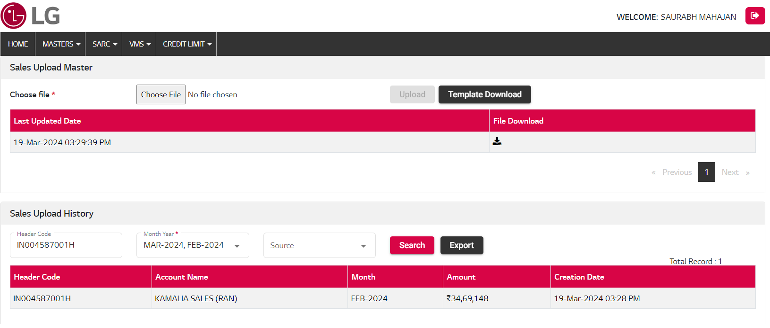

|  |  |  |
| --- | --- | --- |
| BACKEND (NEXTDNET) | | |
| Package Name | **Object Name** | **Remarks** |
| CL_SALES_PKG | SALES_TEMP_INSERT_PROC | Sales Upload Temp Insert |
| CL_SALES_PKG | SALES_TEMP_VALID_PROC | Sales Upload Temp Validate |
| CL_SALES_PKG | SALES_MAIN_INSERT_PROC | Sales Upload Main Insert |
| CL_SALES_PKG | SALES_READ_PROC | Sales Upload Read |

|  |  |  |  |
| --- | --- | --- | --- |
|  |  | API | |
| SNo. | **Action** | **API Name** | **Remarks** |
| 1. | Template Download | N/A | Excel format download with Header Code & Last 24-Months year dynamic. |
| 2. | Upload Button | api/UtilitiesARCreditLimit/SalesUpload | Upload template data for Sales upload. |
| 3. | Grid View (Upload Logs) | api/UtilitiesARCreditLimit/UploadFilesLogRead?ProcessType=SALES_UPLOAD | Show all uploaded file logs. |
| 4. | File Download | api/UtilitiesARCreditLimit/FileDownload | Upload Log file download |
| 5. | Grid View (Sales Upload List) | api/UtilitiesARCreditLimit/ReadSalesData | Shows the list of Sales Upload, Search according to parameters. (History, Current data) |
| 6. | Export Button | api/UtilitiesARCreditLimit/ReadSalesData | Export excel report |

| Model Name | | CREDIT LIMIT SYSTEM | | | | Table Owner | |  | |
| --- | --- | --- | --- | --- | --- | --- | --- | --- | --- |
| Table Name | | CL_SALE_UPLOAD_MASTER_TMP_TB | | | | Entity Name | |  | |
| Table Description | | Sales Upload Temp Table | | | | | | | |
| Column Name | Key | | Data Type | Length | Nullable | | Attribute Name | | Default Value |
| HEADER_CODE |  | | VARCHAR2(100) |  | Y | |  | |  |
| CLOSING_MONTH |  | | DATE |  | Y | |  | |  |
| MONTH_YEAR |  | | VARCHAR2(50) |  | Y | |  | |  |
| SALE_AMOUNT |  | | NUMBER(18,2) |  | Y | |  | |  |
| STATUS |  | | VARCHAR2(10) |  | Y | |  | |  |
| REMARKS |  | | VARCHAR2(500) |  | Y | |  | |  |
| ROW_NUMBER |  | | NUMBER |  | Y | |  | |  |
| CREATED_BY |  | | VARCHAR2(250) |  | Y | |  | |  |
| CREATION_DATE |  | | DATE |  | Y | |  | | SYSDATE |
| LAST_UPDATED_BY |  | | VARCHAR2(250) |  | Y | |  | |  |
| LAST_UPDATED_DATE |  | | DATE |  | Y | |  | | SYSDATE |
| ATTRIBUTE1 |  | | VARCHAR2(500) |  | Y | |  | |  |
| ATTRIBUTE2 |  | | VARCHAR2(500) |  | Y | |  | |  |
| ATTRIBUTE3 |  | | VARCHAR2(500) |  | Y | |  | |  |
| ATTRIBUTE4 |  | | VARCHAR2(500) |  | Y | |  | |  |
| ATTRIBUTE5 |  | | VARCHAR2(500) |  | Y | |  | |  |
| ATTRIBUTE6 |  | | NUMBER |  | Y | |  | |  |
| ATTRIBUTE7 |  | | NUMBER |  | Y | |  | |  |
| ATTRIBUTE8 |  | | NUMBER |  | Y | |  | |  |
| ATTRIBUTE9 |  | | NUMBER |  | Y | |  | |  |
| ATTRIBUTE10 |  | | DATE |  | Y | |  | |  |
| ATTRIBUTE11 |  | | DATE |  | Y | |  | |  |
| REQ_ID |  | | NUMBER |  | Y | |  | |  |

| Model Name | | CREDIT LIMIT SYSTEM | | | Table Owner | |  | | |
| --- | --- | --- | --- | --- | --- | --- | --- | --- | --- |
| Table Name | | CL_SALE_UPLOAD_MASTER_TMP_ERR | | | Entity Name | |  | | |
| Table Description | | Sales Upload Error Table | | | | | | | |
| Column Name | Key | | Data Type | Length | | Nullable | | Attribute Name | Default Value |
| HEADER_CODE |  | | VARCHAR2(100) |  | | Y | |  |  |
| CLOSING_MONTH |  | | DATE |  | | Y | |  |  |
| MONTH_YEAR |  | | VARCHAR2(50) |  | | Y | |  |  |
| SALE_AMOUNT |  | | NUMBER(18,2) |  | | Y | |  |  |
| STATUS |  | | VARCHAR2(10) |  | | Y | |  |  |
| REMARKS |  | | VARCHAR2(500) |  | | Y | |  |  |
| ROW_NUMBER |  | | NUMBER |  | | Y | |  |  |
| CREATED_BY |  | | VARCHAR2(250) |  | | Y | |  |  |
| CREATION_DATE |  | | DATE |  | | Y | |  | SYSDATE |
| LAST_UPDATED_BY |  | | VARCHAR2(250) |  | | Y | |  |  |
| LAST_UPDATED_DATE |  | | DATE |  | | Y | |  | SYSDATE |
| ATTRIBUTE1 |  | | VARCHAR2(500) |  | | Y | |  |  |
| ATTRIBUTE2 |  | | VARCHAR2(500) |  | | Y | |  |  |
| ATTRIBUTE3 |  | | VARCHAR2(500) |  | | Y | |  |  |
| ATTRIBUTE4 |  | | VARCHAR2(500) |  | | Y | |  |  |
| ATTRIBUTE5 |  | | VARCHAR2(500) |  | | Y | |  |  |
| ATTRIBUTE6 |  | | NUMBER |  | | Y | |  |  |
| ATTRIBUTE7 |  | | NUMBER |  | | Y | |  |  |
| ATTRIBUTE8 |  | | NUMBER |  | | Y | |  |  |
| ATTRIBUTE9 |  | | NUMBER |  | | Y | |  |  |
| ATTRIBUTE10 |  | | DATE |  | | Y | |  |  |
| ATTRIBUTE11 |  | | DATE |  | | Y | |  |  |

| Model Name | | CREDIT LIMIT SYSTEM | | | Table Owner | |  | | |
| --- | --- | --- | --- | --- | --- | --- | --- | --- | --- |
| Table Name | | CL_SALE_UPLOAD_MASTER_TB | | | Entity Name | |  | | |
| Table Description | | Sales Upload Table | | | | | | | |
| Column Name | Key | | Data Type | Length | | Nullable | | Attribute Name | Default Value |
| ID |  | | NUMBER |  | | Y | |  |  |
| HEADER_CODE |  | | VARCHAR2(100) |  | | Y | |  |  |
| CLOSING_MONTH |  | | DATE |  | | Y | |  |  |
| MONTH_YEAR |  | | VARCHAR2(50) |  | | Y | |  |  |
| SALE_AMOUNT |  | | NUMBER(18,2) |  | | Y | |  |  |
| STATUS |  | | VARCHAR2(10) |  | | Y | |  |  |
| REMARKS |  | | VARCHAR2(500) |  | | Y | |  |  |
| ROW_NUMBER |  | | NUMBER |  | | Y | |  |  |
| CREATED_BY |  | | VARCHAR2(250) |  | | Y | |  |  |
| CREATION_DATE |  | | DATE |  | | Y | |  |  |
| LAST_UPDATED_BY |  | | VARCHAR2(250) |  | | Y | |  |  |
| LAST_UPDATED_DATE |  | | DATE |  | | Y | |  |  |
| ATTRIBUTE1 |  | | VARCHAR2(500) |  | | Y | |  |  |
| ATTRIBUTE2 |  | | VARCHAR2(500) |  | | Y | |  |  |
| ATTRIBUTE3 |  | | VARCHAR2(500) |  | | Y | |  |  |
| ATTRIBUTE4 |  | | VARCHAR2(500) |  | | Y | |  |  |
| ATTRIBUTE5 |  | | VARCHAR2(500) |  | | Y | |  |  |
| ATTRIBUTE6 |  | | NUMBER |  | | Y | |  |  |
| ATTRIBUTE7 |  | | NUMBER |  | | Y | |  |  |
| ATTRIBUTE8 |  | | NUMBER |  | | Y | |  |  |
| ATTRIBUTE9 |  | | NUMBER |  | | Y | |  |  |
| ATTRIBUTE10 |  | | DATE |  | | Y | |  |  |
| ATTRIBUTE11 |  | | DATE |  | | Y | |  |  |
| REQ_ID |  | | NUMBER |  | | Y | |  |  |

### Insurance Upload

Insurance Upload Process:-

1. Download template excel file.
2. Fill the data in template format with Header Code wise & insurance details.
3. Upload the same file with UPLOAD button.
4. If any issues occurred in data while uploading show the error list and rectify the issues. After all issues resolved template file data uploaded successfully.
5. Show all uploaded file List in Grid view (History, Current) and download the same uploaded file.
6. Insurance Upload List data show. Search here with Header Code or Data Source wise respective parameters.

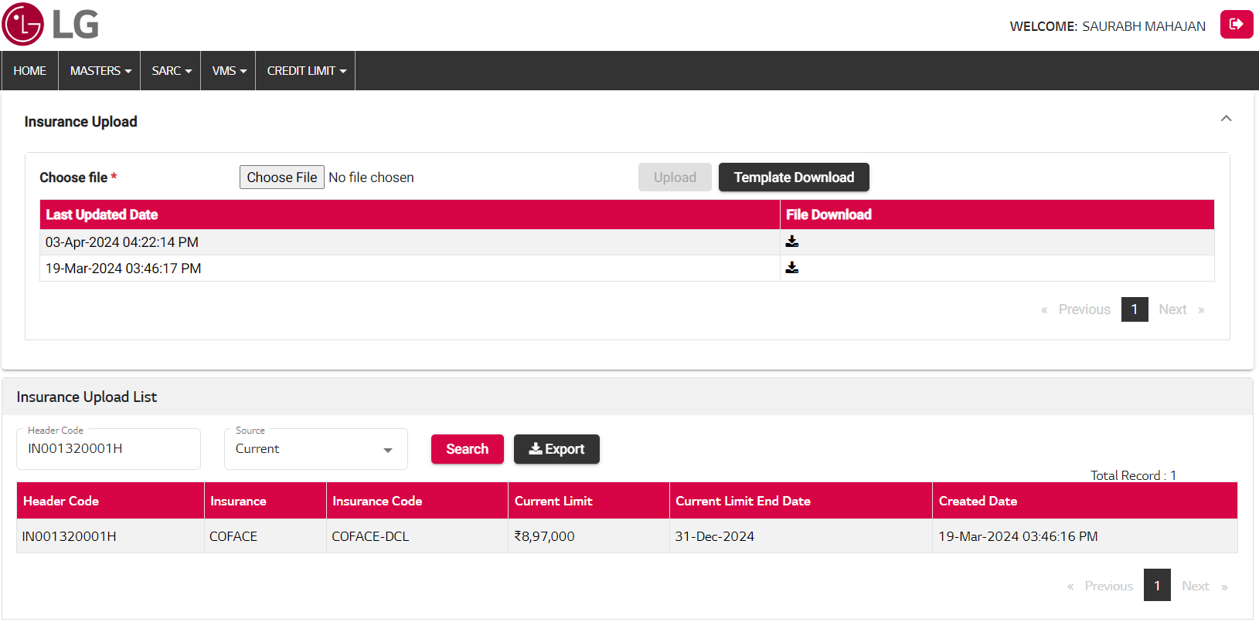

|  |  |  |
| --- | --- | --- |
| BACKEND (NEXTDNET) | | |
| Package Name | **Object Name** | **Remarks** |
| CL_INSURANCE_PKG | INSURANCE_TEMP_INSERT_PROC | Insurance Temp Insert |
| CL_INSURANCE_PKG | INSURANCE_TEMP_VALID_PROC | Insurance Temp Validate |
| CL_INSURANCE_PKG | INSURANCE_MAIN_INSERT_PROC | Insurance Main Insert |
| CL_INSURANCE_PKG | INSURANCE_READ_PROC | Insurance Read |

|  |  |  |  |
| --- | --- | --- | --- |
|  |  | API | |
| SNo. | **Action** | **API Name** | **Remarks** |
| 1. | Template Download | N/A | Excel format download with Header Code & Insurance detail columns. |
| 2. | Upload Button | api/UtilitiesARCreditLimit/InsuranceUpload | Upload template data for Insurance details upload. |
| 3. | Grid View (Upload Logs) | api/UtilitiesARCreditLimit/UploadFilesLogRead?ProcessType=INSURANCE_UPLOAD | Show all uploaded file logs. |
| 4. | File Download | api/UtilitiesARCreditLimit/FileDownload | Upload Log file download |
| 5. | Grid View (Insurance Upload List) | api/UtilitiesARCreditLimit/ReadInsuranceData | Shows the list of Insurance Upload, Search according to parameters. (History, Current data) |
| 6. | Export Button | api/UtilitiesARCreditLimit/ReadInsuranceData | Export excel report |

| Model Name | | CREDIT LIMIT SYSTEM | | | Table Owner | |  | |
| --- | --- | --- | --- | --- | --- | --- | --- | --- |
| Table Name | | CL_INSURANCE_TMP_TB | | | Entity Name | |  | |
| Table Description | | Insurance Upload Temp Table | | | | | | |
| Column Name | Key | | Data Type | Length | | Nullable | Attribute Name | Default Value |
| HEADER_CODE |  | | VARCHAR2(100) |  | | Y |  |  |
| INSURANCE_CODE |  | | VARCHAR2(250) |  | | Y |  |  |
| INSURANCE |  | | VARCHAR2(500) |  | | Y |  |  |
| CURRENT_LIMIT |  | | NUMBER(18,2) |  | | Y |  |  |
| LIMIT_END_DATE |  | | DATE |  | | Y |  |  |
| STATUS |  | | VARCHAR2(100) |  | | Y |  |  |
| REMARKS |  | | VARCHAR2(500) |  | | Y |  |  |
| ROW_NUMBER |  | | NUMBER |  | | Y |  |  |
| REQ_ID |  | | NUMBER |  | | Y |  |  |
| CREATED_BY |  | | VARCHAR2(250) |  | | Y |  |  |
| CREATION_DATE |  | | DATE |  | | Y |  | SYSDATE |
| LAST_UPDATED_BY |  | | VARCHAR2(250) |  | | Y |  |  |
| LAST_UPDATED_DATE |  | | DATE |  | | Y |  | SYSDATE |
| ATTRIBUTE1 |  | | VARCHAR2(500) |  | | Y |  |  |
| ATTRIBUTE2 |  | | VARCHAR2(500) |  | | Y |  |  |
| ATTRIBUTE3 |  | | VARCHAR2(500) |  | | Y |  |  |
| ATTRIBUTE4 |  | | VARCHAR2(500) |  | | Y |  |  |
| ATTRIBUTE5 |  | | VARCHAR2(500) |  | | Y |  |  |
| ATTRIBUTE6 |  | | NUMBER |  | | Y |  |  |
| ATTRIBUTE7 |  | | NUMBER |  | | Y |  |  |
| ATTRIBUTE8 |  | | NUMBER |  | | Y |  |  |
| ATTRIBUTE9 |  | | NUMBER |  | | Y |  |  |
| ATTRIBUTE10 |  | | DATE |  | | Y |  |  |
| ATTRIBUTE11 |  | | DATE |  | | Y |  |  |

| Model Name | | CREDIT LIMIT SYSTEM | | | Table Owner | |  | | |
| --- | --- | --- | --- | --- | --- | --- | --- | --- | --- |
| Table Name | | CL_INSURANCE_ERR | | | Entity Name | |  | | |
| Table Description | | Insurance Upload Error Table | | | | | | | |
| Column Name | Key | | Data Type | Length | | Nullable | | Attribute Name | Default Value |
| HEADER_CODE |  | | VARCHAR2(100) |  | | Y | |  |  |
| INSURANCE_CODE |  | | VARCHAR2(250) |  | | Y | |  |  |
| INSURANCE |  | | VARCHAR2(500) |  | | Y | |  |  |
| CURRENT_LIMIT |  | | NUMBER(18,2) |  | | Y | |  |  |
| LIMIT_END_DATE |  | | DATE |  | | Y | |  |  |
| STATUS |  | | VARCHAR2(100) |  | | Y | |  |  |
| REMARKS |  | | VARCHAR2(500) |  | | Y | |  |  |
| ROW_NUMBER |  | | NUMBER |  | | Y | |  |  |
| REQ_ID |  | | NUMBER |  | | Y | |  |  |
| CREATED_BY |  | | VARCHAR2(250) |  | | Y | |  |  |
| CREATION_DATE |  | | DATE |  | | Y | |  | SYSDATE |
| LAST_UPDATED_BY |  | | VARCHAR2(250) |  | | Y | |  |  |
| LAST_UPDATED_DATE |  | | DATE |  | | Y | |  | SYSDATE |
| ATTRIBUTE1 |  | | VARCHAR2(500) |  | | Y | |  |  |
| ATTRIBUTE2 |  | | VARCHAR2(500) |  | | Y | |  |  |
| ATTRIBUTE3 |  | | VARCHAR2(500) |  | | Y | |  |  |
| ATTRIBUTE4 |  | | VARCHAR2(500) |  | | Y | |  |  |
| ATTRIBUTE5 |  | | VARCHAR2(500) |  | | Y | |  |  |
| ATTRIBUTE6 |  | | NUMBER |  | | Y | |  |  |
| ATTRIBUTE7 |  | | NUMBER |  | | Y | |  |  |
| ATTRIBUTE8 |  | | NUMBER |  | | Y | |  |  |
| ATTRIBUTE9 |  | | NUMBER |  | | Y | |  |  |
| ATTRIBUTE10 |  | | DATE |  | | Y | |  |  |
| ATTRIBUTE11 |  | | DATE |  | | Y | |  |  |

| Model Name | | CREDIT LIMIT SYSTEM | | | Table Owner | |  | | |
| --- | --- | --- | --- | --- | --- | --- | --- | --- | --- |
| Table Name | | CL_INSURANCE_TB | | | Entity Name | |  | | |
| Table Description | | Insurance Upload Table | | | | | | | |
| Column Name | Key | | Data Type | Length | | Nullable | | Attribute Name | Default Value |
| HEADER_CODE |  | | VARCHAR2(100) |  | | Y | |  |  |
| INSURANCE_CODE |  | | VARCHAR2(250) |  | | Y | |  |  |
| INSURANCE |  | | VARCHAR2(250) |  | | Y | |  |  |
| CURRENT_LIMIT |  | | NUMBER(18,2) |  | | Y | |  |  |
| LIMIT_END_DATE |  | | DATE |  | | Y | |  |  |
| STATUS |  | | VARCHAR2(100) |  | | Y | |  |  |
| REMARKS |  | | VARCHAR2(500) |  | | Y | |  |  |
| ROW_NUMBER |  | | NUMBER |  | | Y | |  |  |
| REQ_ID |  | | NUMBER |  | | Y | |  |  |
| CREATED_BY |  | | VARCHAR2(250) |  | | Y | |  |  |
| CREATION_DATE |  | | DATE |  | | Y | |  | SYSDATE |
| LAST_UPDATED_BY |  | | VARCHAR2(250) |  | | Y | |  |  |
| LAST_UPDATED_DATE |  | | DATE |  | | Y | |  | SYSDATE |
| ATTRIBUTE1 |  | | VARCHAR2(500) |  | | Y | |  |  |
| ATTRIBUTE2 |  | | VARCHAR2(500) |  | | Y | |  |  |
| ATTRIBUTE3 |  | | VARCHAR2(500) |  | | Y | |  |  |
| ATTRIBUTE4 |  | | VARCHAR2(500) |  | | Y | |  |  |
| ATTRIBUTE5 |  | | VARCHAR2(500) |  | | Y | |  |  |
| ATTRIBUTE6 |  | | NUMBER |  | | Y | |  |  |
| ATTRIBUTE7 |  | | NUMBER |  | | Y | |  |  |
| ATTRIBUTE8 |  | | NUMBER |  | | Y | |  |  |
| ATTRIBUTE9 |  | | NUMBER |  | | Y | |  |  |
| ATTRIBUTE10 |  | | DATE |  | | Y | |  |  |
| ATTRIBUTE11 |  | | DATE |  | | Y | |  |  |

### OD Upload

OD Upload Process:-

1. Download template excel file.
2. Fill the data in template format with Header Code & Last 12-months OD dynamic columns.
3. Upload the same file with UPLOAD button.
4. If any issues occurred in data while uploading show the error list and rectify the issues. After all issues resolved template file data uploaded successfully.
5. Show all uploaded file List in Grid view (History, Current) and download the same uploaded file.
6. OD Upload List data show. Search here with Header Code or Data Source wise respective parameters.

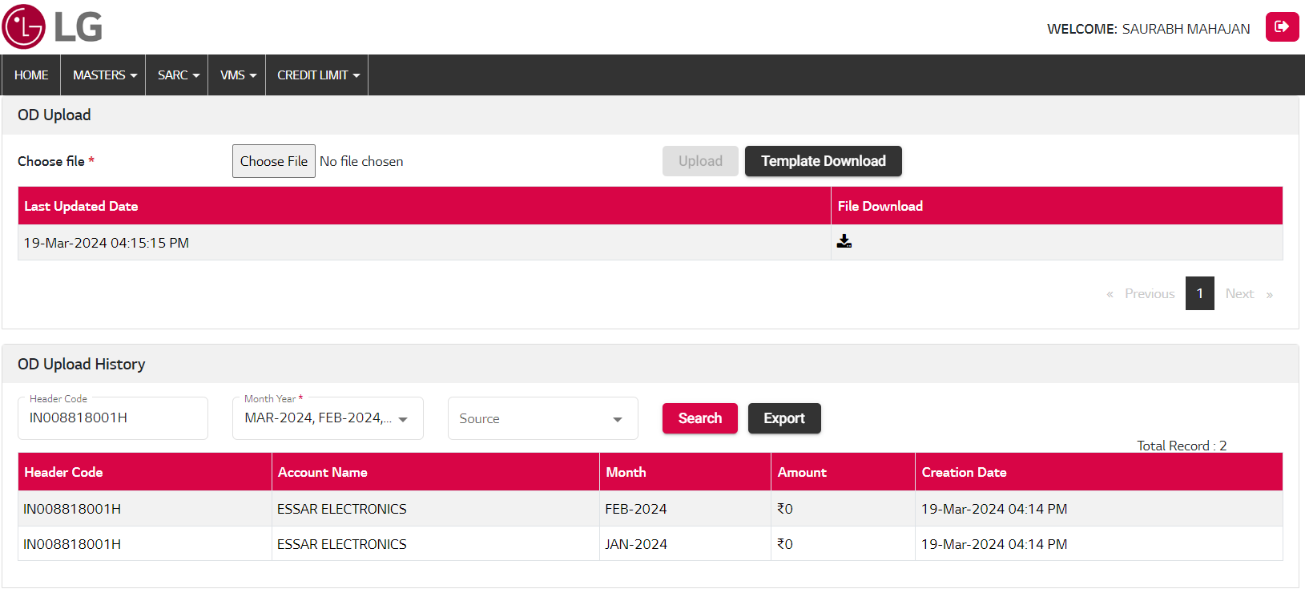

|  |  |  |
| --- | --- | --- |
| BACKEND (NEXTDNET) | | |
| Package Name | **Object Name** | **Remarks** |
| CL_OD_PKG | OD_TEMP_INSERT_PROC | OD Upload Temp Insert |
| CL_OD_PKG | OD_TEMP_VALID_PROC | OD Upload Temp Validate |
| CL_OD_PKG | OD_MAIN_INSERT_PROC | OD Upload Main Insert |
| CL_OD_PKG | OD_READ_PROC | OD Upload Read |

|  |  |  |  |
| --- | --- | --- | --- |
|  |  | API | |
| SNo. | **Action** | **API Name** | **Remarks** |
| 1. | Template Download | N/A | Excel format download with Header Code & Last 12-months dynamic columns. |
| 2. | Upload Button | api/UtilitiesARCreditLimit/ODUpload | Upload template data for OD details upload. |
| 3. | Grid View (Upload Logs) | api/UtilitiesARCreditLimit/UploadFilesLogRead?ProcessType=OD_UPLOAD | Show all uploaded file logs. |
| 4. | File Download | api/UtilitiesARCreditLimit/FileDownload | Upload Log file download |
| 5. | Grid View (OD Upload List) | api/UtilitiesARCreditLimit/ReadODData | Shows the list of OD Upload, Search according to parameters. (History, Current data) |
| 6. | Export Button | api/UtilitiesARCreditLimit/ReadODData | Export excel report |

| Model Name | | CREDIT LIMIT SYSTEM | | | Table Owner | |  | | |
| --- | --- | --- | --- | --- | --- | --- | --- | --- | --- |
| Table Name | | CL_OD_UPLOAD_TMP_TB | | | Entity Name | |  | | |
| Table Description | | OD Upload Temp Table | | | | | | | |
| Column Name | Key | | Data Type | Length | | Nullable | | Attribute Name | Default Value |
| HEADER_CODE |  | | VARCHAR2(100) |  | | Y | |  |  |
| MONTH_YEAR |  | | VARCHAR2(50) |  | | Y | |  |  |
| OD_AMOUNT |  | | NUMBER(18,2) |  | | Y | |  |  |
| STATUS |  | | VARCHAR2(250) |  | | Y | |  |  |
| REMARKS |  | | VARCHAR2(500) |  | | Y | |  |  |
| ROW_NUMBER |  | | NUMBER |  | | Y | |  |  |
| REQ_ID |  | | NUMBER |  | | Y | |  |  |
| CREATED_BY |  | | VARCHAR2(250) |  | | Y | |  |  |
| CREATION_DATE |  | | DATE |  | | Y | |  | SYSDATE |
| LAST_UPDATED_BY |  | | VARCHAR2(250) |  | | Y | |  |  |
| LAST_UPDATED_DATE |  | | DATE |  | | Y | |  | SYSDATE |
| ATTRIBUTE1 |  | | VARCHAR2(500) |  | | Y | |  |  |
| ATTRIBUTE2 |  | | VARCHAR2(500) |  | | Y | |  |  |
| ATTRIBUTE3 |  | | VARCHAR2(500) |  | | Y | |  |  |
| ATTRIBUTE4 |  | | VARCHAR2(500) |  | | Y | |  |  |
| ATTRIBUTE5 |  | | VARCHAR2(500) |  | | Y | |  |  |
| ATTRIBUTE6 |  | | NUMBER |  | | Y | |  |  |
| ATTRIBUTE7 |  | | NUMBER |  | | Y | |  |  |
| ATTRIBUTE8 |  | | NUMBER |  | | Y | |  |  |
| ATTRIBUTE9 |  | | NUMBER |  | | Y | |  |  |
| ATTRIBUTE10 |  | | DATE |  | | Y | |  |  |
| ATTRIBUTE11 |  | | DATE |  | | Y | |  |  |

| Model Name | | CREDIT LIMIT SYSTEM | | | Table Owner | |  | | |
| --- | --- | --- | --- | --- | --- | --- | --- | --- | --- |
| Table Name | | CL_OD_UPLOAD_ERR_TB | | | Entity Name | |  | | |
| Table Description | | OD Upload Error Table | | | | | | | |
| Column Name | Key | | Data Type | Length | | Nullable | | Attribute Name | Default Value |
| HEADER_CODE |  | | VARCHAR2(100) |  | | Y | |  |  |
| MONTH_YEAR |  | | VARCHAR2(50) |  | | Y | |  |  |
| OD_AMOUNT |  | | NUMBER(18,2) |  | | Y | |  |  |
| STATUS |  | | VARCHAR2(250) |  | | Y | |  |  |
| REMARKS |  | | VARCHAR2(500) |  | | Y | |  |  |
| ROW_NUMBER |  | | NUMBER |  | | Y | |  |  |
| REQ_ID |  | | NUMBER |  | | Y | |  |  |
| CREATED_BY |  | | VARCHAR2(250) |  | | Y | |  |  |
| CREATION_DATE |  | | DATE |  | | Y | |  | SYSDATE |
| LAST_UPDATED_BY |  | | VARCHAR2(250) |  | | Y | |  |  |
| LAST_UPDATED_DATE |  | | DATE |  | | Y | |  | SYSDATE |
| ATTRIBUTE1 |  | | VARCHAR2(500) |  | | Y | |  |  |
| ATTRIBUTE2 |  | | VARCHAR2(500) |  | | Y | |  |  |
| ATTRIBUTE3 |  | | VARCHAR2(500) |  | | Y | |  |  |
| ATTRIBUTE4 |  | | VARCHAR2(500) |  | | Y | |  |  |
| ATTRIBUTE5 |  | | VARCHAR2(500) |  | | Y | |  |  |
| ATTRIBUTE6 |  | | NUMBER |  | | Y | |  |  |
| ATTRIBUTE7 |  | | NUMBER |  | | Y | |  |  |
| ATTRIBUTE8 |  | | NUMBER |  | | Y | |  |  |
| ATTRIBUTE9 |  | | NUMBER |  | | Y | |  |  |
| ATTRIBUTE10 |  | | DATE |  | | Y | |  |  |
| ATTRIBUTE11 |  | | DATE |  | | Y | |  |  |

| Model Name | | CREDIT LIMIT SYSTEM | | | Table Owner | |  | | |
| --- | --- | --- | --- | --- | --- | --- | --- | --- | --- |
| Table Name | | CL_OD_UPLOAD_TB | | | Entity Name | |  | | |
| Table Description | | OD Upload Table | | | | | | | |
| Column Name | Key | | Data Type | Length | | Nullable | | Attribute Name | Default Value |
| ID |  | | NUMBER |  | | Y | |  |  |
| HEADER_CODE |  | | VARCHAR2(100) |  | | Y | |  |  |
| MONTH_YEAR |  | | VARCHAR2(50) |  | | Y | |  |  |
| OD_AMOUNT |  | | NUMBER(18,2) |  | | Y | |  |  |
| STATUS |  | | VARCHAR2(250) |  | | Y | |  |  |
| REMARKS |  | | VARCHAR2(500) |  | | Y | |  |  |
| ROW_NUMBER |  | | NUMBER |  | | Y | |  |  |
| REQ_ID |  | | NUMBER |  | | Y | |  |  |
| CREATED_BY |  | | VARCHAR2(250) |  | | Y | |  |  |
| CREATION_DATE |  | | DATE |  | | Y | |  | SYSDATE |
| LAST_UPDATED_BY |  | | VARCHAR2(250) |  | | Y | |  |  |
| LAST_UPDATED_DATE |  | | DATE |  | | Y | |  | SYSDATE |
| ATTRIBUTE1 |  | | VARCHAR2(500) |  | | Y | |  |  |
| ATTRIBUTE2 |  | | VARCHAR2(500) |  | | Y | |  |  |
| ATTRIBUTE3 |  | | VARCHAR2(500) |  | | Y | |  |  |
| ATTRIBUTE4 |  | | VARCHAR2(500) |  | | Y | |  |  |
| ATTRIBUTE5 |  | | VARCHAR2(500) |  | | Y | |  |  |
| ATTRIBUTE6 |  | | NUMBER |  | | Y | |  |  |
| ATTRIBUTE7 |  | | NUMBER |  | | Y | |  |  |
| ATTRIBUTE8 |  | | NUMBER |  | | Y | |  |  |
| ATTRIBUTE9 |  | | NUMBER |  | | Y | |  |  |
| ATTRIBUTE10 |  | | DATE |  | | Y | |  |  |
| ATTRIBUTE11 |  | | DATE |  | | Y | |  |  |

### Collection Upload

Collection Upload Process:-

1. Download template excel file.
2. Fill the data in template format with Header Code & Last 12-months OD dynamic columns.
3. Upload the same file with UPLOAD button.
4. If any issues occurred in data while uploading show the error list and rectify the issues. After all issues resolved template file data uploaded successfully.
5. Show all uploaded file List in Grid view (History, Current) and download the same uploaded file.
6. OD Upload List data show. Search here with Header Code or Data Source wise respective parameters.

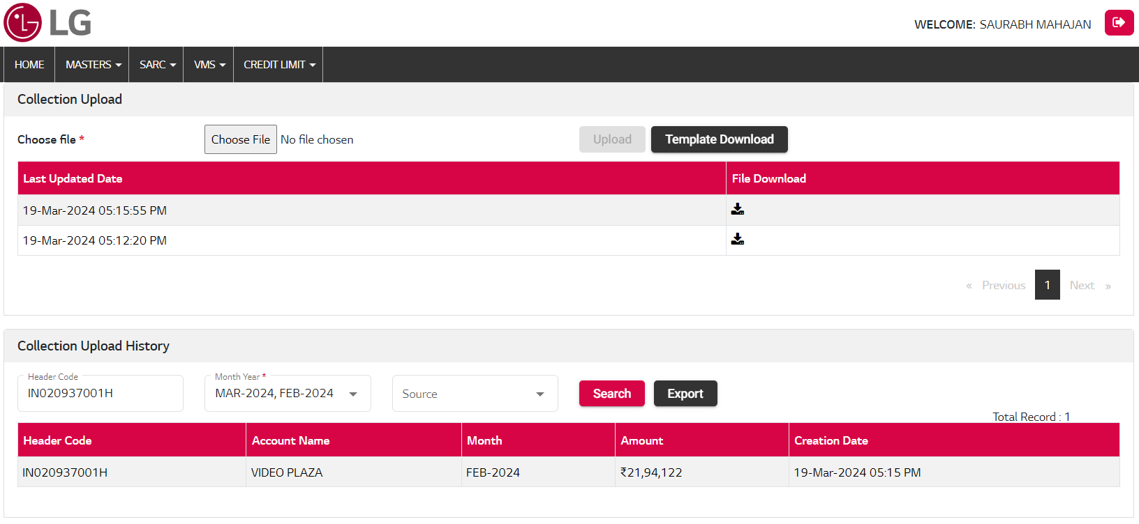

|  |  |  |
| --- | --- | --- |
| BACKEND (NEXTDNET) | | |
| Package Name | **Object Name** | **Remarks** |
| CL_COLLECTION_PKG | COLLECTION_TEMP_INSERT_PROC | Collection Temp Insert |
| CL_COLLECTION_PKG | COLLECTION_TEMP_VALID_PROC | Collection Temp Validate |
| CL_COLLECTION_PKG | COLLECTION_MAIN_INSERT_PROC | Collection Main Insert |
| CL_COLLECTION_PKG | COLLECTION_READ_PROC | Collection Main Read |

|  |  |  |  |
| --- | --- | --- | --- |
|  |  | API | |
| SNo. | **Action** | **API Name** | **Remarks** |
| 1. | Template Download | N/A | Excel format download with Header Code & Last 6-months dynamic columns. |
| 2. | Upload Button | api/UtilitiesARCreditLimit/CollectionUpload | Upload template data for Collection details upload. |
| 3. | Grid View (Upload Logs) | api/UtilitiesARCreditLimit/UploadFilesLogRead?ProcessType=COLLECTION_UPLOAD | Show all uploaded file logs. |
| 4. | File Download | api/UtilitiesARCreditLimit/FileDownload | Upload Log file download |
| 5. | Grid View (Collection Upload List) | api/UtilitiesARCreditLimit/ReadCollectionData | Shows the list of Collection Upload, Search according to parameters. (History, Current data) |
| 6. | Export Button | api/UtilitiesARCreditLimit/ReadCollectionData | Export excel report |

| Model Name | CREDIT LIMIT SYSTEM | | | Table Owner | |  | | |
| --- | --- | --- | --- | --- | --- | --- | --- | --- |
| Table Name | CL_COLLECTION_TMP_TB | | | Entity Name | |  | | |
| Table Description | Collection Upload Temp Table | | | | | | | |
| Column Name | Key | Data Type | Length | | Nullable | | Attribute Name | Default Value |
| HEADER_CODE |  | VARCHAR2(100) |  | | Y | |  |  |
| MONTH_YEAR |  | VARCHAR2(50) |  | | Y | |  |  |
| COLLECTION_AMOUNT |  | NUMBER(18,2) |  | | Y | |  |  |
| STATUS |  | VARCHAR2(250) |  | | Y | |  |  |
| REMARKS |  | VARCHAR2(500) |  | | Y | |  |  |
| ROW_NUMBER |  | NUMBER |  | | Y | |  |  |
| REQ_ID |  | NUMBER |  | | Y | |  |  |
| CREATED_BY |  | VARCHAR2(250) |  | | Y | |  |  |
| CREATION_DATE |  | DATE |  | | Y | |  | SYSDATE |
| LAST_UPDATED_BY |  | VARCHAR2(250) |  | | Y | |  |  |
| LAST_UPDATED_DATE |  | DATE |  | | Y | |  | SYSDATE |
| ATTRIBUTE1 |  | VARCHAR2(500) |  | | Y | |  |  |
| ATTRIBUTE2 |  | VARCHAR2(500) |  | | Y | |  |  |
| ATTRIBUTE3 |  | VARCHAR2(500) |  | | Y | |  |  |
| ATTRIBUTE4 |  | VARCHAR2(500) |  | | Y | |  |  |
| ATTRIBUTE5 |  | VARCHAR2(500) |  | | Y | |  |  |
| ATTRIBUTE6 |  | NUMBER |  | | Y | |  |  |
| ATTRIBUTE7 |  | NUMBER |  | | Y | |  |  |
| ATTRIBUTE8 |  | NUMBER |  | | Y | |  |  |
| ATTRIBUTE9 |  | NUMBER |  | | Y | |  |  |
| ATTRIBUTE10 |  | DATE |  | | Y | |  |  |
| ATTRIBUTE11 |  | DATE |  | | Y | |  |  |

| Model Name | CREDIT LIMIT SYSTEM | | | Table Owner | |  | | |
| --- | --- | --- | --- | --- | --- | --- | --- | --- |
| Table Name | CL_COLLECTION_ERR_TB | | | Entity Name | |  | | |
| Table Description | Collection Upload Error Table | | | | | | | |
| Column Name | Key | Data Type | Length | | Nullable | | Attribute Name | Default Value |
| HEADER_CODE |  | VARCHAR2(100) |  | | Y | |  |  |
| MONTH_YEAR |  | VARCHAR2(50) |  | | Y | |  |  |
| COLLECTION_AMOUNT |  | NUMBER(18,2) |  | | Y | |  |  |
| STATUS |  | VARCHAR2(250) |  | | Y | |  |  |
| REMARKS |  | VARCHAR2(500) |  | | Y | |  |  |
| ROW_NUMBER |  | NUMBER |  | | Y | |  |  |
| REQ_ID |  | NUMBER |  | | Y | |  |  |
| CREATED_BY |  | VARCHAR2(250) |  | | Y | |  |  |
| CREATION_DATE |  | DATE |  | | Y | |  | SYSDATE |
| LAST_UPDATED_BY |  | VARCHAR2(250) |  | | Y | |  |  |
| LAST_UPDATED_DATE |  | DATE |  | | Y | |  | SYSDATE |
| ATTRIBUTE1 |  | VARCHAR2(500) |  | | Y | |  |  |
| ATTRIBUTE2 |  | VARCHAR2(500) |  | | Y | |  |  |
| ATTRIBUTE3 |  | VARCHAR2(500) |  | | Y | |  |  |
| ATTRIBUTE4 |  | VARCHAR2(500) |  | | Y | |  |  |
| ATTRIBUTE5 |  | VARCHAR2(500) |  | | Y | |  |  |
| ATTRIBUTE6 |  | NUMBER |  | | Y | |  |  |
| ATTRIBUTE7 |  | NUMBER |  | | Y | |  |  |
| ATTRIBUTE8 |  | NUMBER |  | | Y | |  |  |
| ATTRIBUTE9 |  | NUMBER |  | | Y | |  |  |
| ATTRIBUTE10 |  | DATE |  | | Y | |  |  |
| ATTRIBUTE11 |  | DATE |  | | Y | |  |  |

| Model Name | CREDIT LIMIT SYSTEM | | | Table Owner | |  | | |
| --- | --- | --- | --- | --- | --- | --- | --- | --- |
| Table Name | CL_COLLECTION_TB | | | Entity Name | |  | | |
| Table Description | Collection Upload Table | | | | | | | |
| Column Name | Key | Data Type | Length | | Nullable | | Attribute Name | Default Value |
| ID |  | NUMBER |  | | Y | |  |  |
| HEADER_CODE |  | VARCHAR2(100) |  | | Y | |  |  |
| MONTH_YEAR |  | VARCHAR2(50) |  | | Y | |  |  |
| COLLECTION_AMOUNT |  | NUMBER(18,2) |  | | Y | |  |  |
| STATUS |  | VARCHAR2(250) |  | | Y | |  |  |
| REMARKS |  | VARCHAR2(500) |  | | Y | |  |  |
| ROW_NUMBER |  | NUMBER |  | | Y | |  |  |
| REQ_ID |  | NUMBER |  | | Y | |  |  |
| CREATED_BY |  | VARCHAR2(250) |  | | Y | |  |  |
| CREATION_DATE |  | DATE |  | | Y | |  | SYSDATE |
| LAST_UPDATED_BY |  | VARCHAR2(250) |  | | Y | |  |  |
| LAST_UPDATED_DATE |  | DATE |  | | Y | |  | SYSDATE |
| ATTRIBUTE1 |  | VARCHAR2(500) |  | | Y | |  |  |
| ATTRIBUTE2 |  | VARCHAR2(500) |  | | Y | |  |  |
| ATTRIBUTE3 |  | VARCHAR2(500) |  | | Y | |  |  |
| ATTRIBUTE4 |  | VARCHAR2(500) |  | | Y | |  |  |
| ATTRIBUTE5 |  | VARCHAR2(500) |  | | Y | |  |  |
| ATTRIBUTE6 |  | NUMBER |  | | Y | |  |  |
| ATTRIBUTE7 |  | NUMBER |  | | Y | |  |  |
| ATTRIBUTE8 |  | NUMBER |  | | Y | |  |  |
| ATTRIBUTE9 |  | NUMBER |  | | Y | |  |  |
| ATTRIBUTE10 |  | DATE |  | | Y | |  |  |
| ATTRIBUTE11 |  | DATE |  | | Y | |  |  |

| Model Name | CREDIT LIMIT SYSTEM | | | Table Owner | |  | | |
| --- | --- | --- | --- | --- | --- | --- | --- | --- |
| Table Name | CL_UPLOAD_FILE_LOG_TB | | | Entity Name | |  | | |
| Table Description | Upload all upload file Log Table | | | | | | | |
| Column Name | Key | Data Type | Length | | Nullable | | Attribute Name | Default Value |
| ID |  | NUMBER |  | | Y | |  |  |
| PROCESS_TYPE |  | VARCHAR2(100) |  | |  | |  |  |
| FILE_NAME_PATH |  | VARCHAR2(1000) |  | |  | |  |  |
| STATUS |  | VARCHAR2(100) |  | | Y | |  |  |
| REMARKS |  | VARCHAR2(500) |  | | Y | |  |  |
| CREATED_BY |  | VARCHAR2(250) |  | | Y | |  |  |
| CREATION_DATE |  | DATE |  | | Y | |  |  |
| LAST_UPDATED_BY |  | VARCHAR2(250) |  | | Y | |  |  |
| LAST_UPDATED_DATE |  | DATE |  | | Y | |  |  |
| ATTRIBUTE1 |  | VARCHAR2(500) |  | | Y | |  |  |
| ATTRIBUTE2 |  | VARCHAR2(500) |  | | Y | |  |  |
| ATTRIBUTE3 |  | VARCHAR2(500) |  | | Y | |  |  |
| ATTRIBUTE4 |  | VARCHAR2(500) |  | | Y | |  |  |
| ATTRIBUTE5 |  | VARCHAR2(500) |  | | Y | |  |  |
| ATTRIBUTE6 |  | NUMBER |  | | Y | |  |  |
| ATTRIBUTE7 |  | NUMBER |  | | Y | |  |  |
| ATTRIBUTE8 |  | NUMBER |  | | Y | |  |  |
| ATTRIBUTE9 |  | NUMBER |  | | Y | |  |  |
| ATTRIBUTE10 |  | DATE |  | | Y | |  |  |
| ATTRIBUTE11 |  | DATE |  | | Y | |  |  |

### Credit Limit Request

### Credit Limit Request

New Credit Limit Request submit process with Header Code wise or Bulk Upload Request (If allows):-

1. Search Header Code of all basic details, Sales History, Last Six Month Sales and Payment Trend, Month End OD History Last 12 months, Enclosed Financial Statements, applicable notes etc.
2. Enter Future sales plan (Next six months).
3. New Credit limit request amount enter, New Request limit must be greater than current limit assign.
4. Remarks enter.
5. Enclosed Financial Statements (If No please collect audited / Provision soon) upload.
6. After all validation success. Click on SUBMIT button for process the new request.
7. When Header Code of Request is In Process then not submit new request either Approve/Reject.
8. After Request submitted successfully. An auto email sent to concern person with all requested detail in email attachment PDF file.

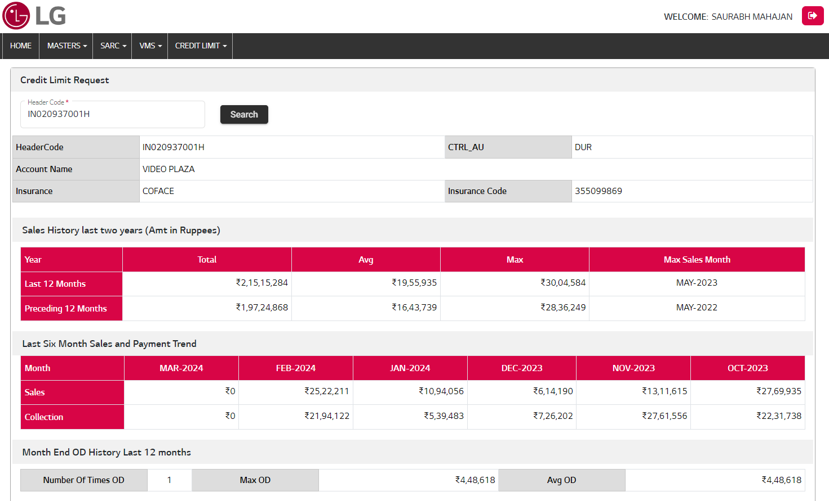

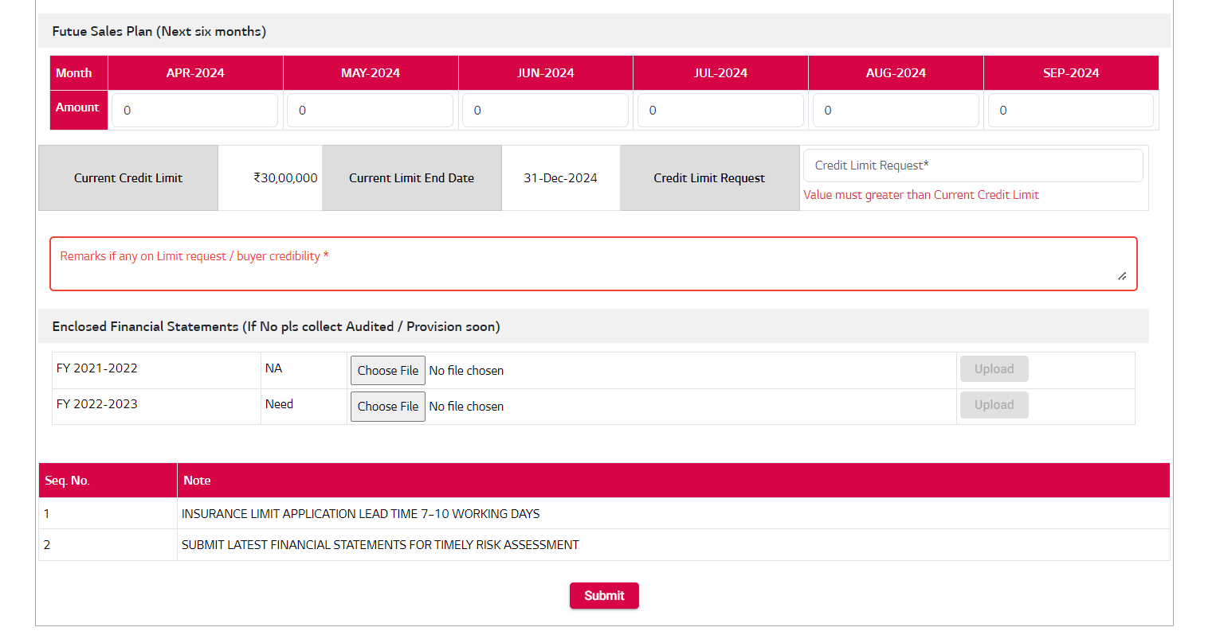

### Bulk Credit Limit Request

When required bulk request admin can manage the Bulk Request process Enable/ Disable any times.

1. Download template file.
2. Fill the excel template file for bulk request.
3. Upload the same file with UPLOAD button.
4. If any issues occurred in data while uploading show the error list and rectify the issues. After all issues resolved template file data uploaded successfully.
5. After Request submitted successfully. An auto email sent to concern person with all requested detail in email attachment PDF File.
6. When click on “**New Request**” button redirect to New Request entry form.



|  |  |  |
| --- | --- | --- |
| BACKEND (NEXTDNET) | | |
| Package Name | **Object Name** | **Remarks** |
| CL_CREDIT_LIMIT_PKG | HEADER_DTL_READ_PROC | History Detail Read |
| CL_CREDIT_LIMIT_PKG | SALES_HISTORY_READ_PROC | Sales History Detail Read |
| CL_CREDIT_LIMIT_PKG | SALES_PAYMENT_TREND_PROC | Sales Payment Trend Read |
| CL_CREDIT_LIMIT_PKG | OD_HISTORY_SUMMARY_READ_PROC | OD History Summary Read |
| CL_CREDIT_LIMIT_PKG | FUTURE_SALES_PLAN_READ_PROC | Future Sales Plan Read |
| CL_CREDIT_LIMIT_PKG | CREDIT_LIMIT_REQUEST_SAVE_PROC | Credit Limit New Request Submit |
| CL_CREDIT_LIMIT_PKG | FINANCIAL_STATEMENT_SAVE_PROC | Financial Statement Insert |
| CL_CREDIT_LIMIT_PKG | CL_NOTES_READ_PROC | CL Notes Read |
| CL_CREDIT_LIMIT_PKG | REQUEST_NOTES_SAVE_PROC | Request Notes Insert |
| CL_CREDIT_LIMIT_PKG | CL_BULK_UPLOAD_INS_TMP_PROC | Bulk Request data insert in Temp table |
| CL_CREDIT_LIMIT_PKG | CL_BULK_UPLOAD_VALIDATE_PROC | Bulk Request upload data validate |
| CL_CREDIT_LIMIT_PKG | CL_BULK_UPLOAD_INS_MAIN_PROC | Bulk Request Upload in Insert in Main table |

|  |  |  |  |
| --- | --- | --- | --- |
|  |  | API | |
| SNo. | **Action** | **API Name** | **Remarks** |
| 1. | Bulk Request Button | api/LookupMaster/ReadLookup  (SystemName : "AR_CREDIT_LIMIT_BULK_REQUEST_ALLOW") | Bulk Request button show/hide |
| 2. | Search Button | api/ARCreditLimit/ReadHeaderCodeDetail | Read Header Code of all basic details, Sales History, Last Six Month Sales and Payment Trend, Month End OD History Last 12 months, Enclosed Financial Statements, applicable notes etc. |
| 3. | Upload Button | api/ARCreditLimit/FYAttachmentUpload | Enclosed Financial Statements Upload |
| 4. | Submit | api/ARCreditLimit/CreditLimitRequestSave | Submit New Credit Limit Request |
| 5. | Bulk Request | api/ARCreditLimit/CreditLimitRequestBulk | Bulk Request Upload for credit limit. |

| Model Name | CREDIT LIMIT SYSTEM | | | Table Owner | |  | |
| --- | --- | --- | --- | --- | --- | --- | --- |
| Table Name | CL_CREDIT_LIMIT_REQUEST_TB | | | Entity Name | |  | |
| Table Description | Credit Limit Request Detail Table | | | | | | |
| Column Name | Key | Data Type | Length | Nullable | Attribute Name | | Default Value |
| REQ_ID |  | NUMBER |  | Y |  | |  |
| HEADER_CODE |  | VARCHAR2(100) |  | Y |  | |  |
| CTRL_AU |  | VARCHAR2(50) |  | Y |  | |  |
| CURRENT_CL_AMOUNT |  | NUMBER(18,2) |  | Y |  | |  |
| CURRENT_CL_END_DATE |  | DATE |  | Y |  | |  |
| REQUEST_CL_AMOUNT |  | NUMBER(18,2) |  | Y |  | |  |
| NEW_LIMIT_AMOUNT |  | NUMBER(18,2) |  | Y |  | |  |
| INSURANCE_CODE |  | VARCHAR2(250) |  | Y |  | |  |
| INSURANCE |  | VARCHAR2(500) |  | Y |  | |  |
| STATUS |  | VARCHAR2(250) |  | Y |  | |  |
| REMARKS |  | VARCHAR2(1000) |  | Y |  | |  |
| CREATED_BY |  | VARCHAR2(250) |  | Y |  | |  |
| CREATION_DATE |  | DATE |  | Y |  | | SYSDATE |
| LAST_UPDATED_BY |  | VARCHAR2(250) |  | Y |  | |  |
| LAST_UPDATED_DATE |  | DATE |  | Y |  | | SYSDATE |
| ATTRIBUTE1 |  | VARCHAR2(500) |  | Y |  | |  |
| ATTRIBUTE2 |  | VARCHAR2(500) |  | Y |  | |  |
| ATTRIBUTE3 |  | VARCHAR2(500) |  | Y |  | |  |
| ATTRIBUTE4 |  | VARCHAR2(500) |  | Y |  | |  |
| ATTRIBUTE5 |  | VARCHAR2(500) |  | Y |  | |  |
| ATTRIBUTE6 |  | NUMBER |  | Y |  | |  |
| ATTRIBUTE7 |  | NUMBER |  | Y |  | |  |
| ATTRIBUTE8 |  | NUMBER |  | Y |  | |  |
| ATTRIBUTE9 |  | NUMBER |  | Y |  | |  |
| ATTRIBUTE10 |  | DATE |  | Y |  | |  |
| ATTRIBUTE11 |  | DATE |  | Y |  | |  |
| BULK_ID |  | NUMBER |  | Y |  | |  |
| APPROVAL_REMARK |  | VARCHAR2(1000) |  | Y |  | |  |
| EMAIL_SENT |  | VARCHAR2(100) |  | Y |  | |  |
| PROCESS_TYPE |  | VARCHAR2(500) |  | Y |  | |  |

| Model Name | CREDIT LIMIT SYSTEM | | | Table Owner | |  | |
| --- | --- | --- | --- | --- | --- | --- | --- |
| Table Name | CL_FUTURE_SALES_PLAN_TB | | | Entity Name | |  | |
| Table Description | Future Sales Plan Detail Table | | | | | | |
| Column Name | Key | Data Type | Length | | Nullable | Attribute Name | Default Value |
| REQ_ID |  | NUMBER |  | | Y |  |  |
| HEADER_CODE |  | VARCHAR2(250) |  | | Y |  |  |
| MONTH_YEAR |  | VARCHAR2(250) |  | | Y |  |  |
| SALE_AMOUNT |  | NUMBER(18,2) |  | | Y |  |  |
| CREATED_BY |  | VARCHAR2(250) |  | | Y |  |  |
| CREATION_DATE |  | DATE |  | | Y |  | SYSDATE |
| LAST_UPDATED_BY |  | VARCHAR2(250) |  | | Y |  |  |
| LAST_UPDATED_DATE |  | DATE |  | | Y |  | SYSDATE |
| ATTRIBUTE1 |  | VARCHAR2(500) |  | | Y |  |  |
| ATTRIBUTE2 |  | VARCHAR2(500) |  | | Y |  |  |
| ATTRIBUTE3 |  | VARCHAR2(500) |  | | Y |  |  |
| ATTRIBUTE4 |  | VARCHAR2(500) |  | | Y |  |  |
| ATTRIBUTE5 |  | VARCHAR2(500) |  | | Y |  |  |
| ATTRIBUTE6 |  | NUMBER |  | | Y |  |  |
| ATTRIBUTE7 |  | NUMBER |  | | Y |  |  |
| ATTRIBUTE8 |  | NUMBER |  | | Y |  |  |
| ATTRIBUTE9 |  | NUMBER |  | | Y |  |  |
| ATTRIBUTE10 |  | DATE |  | | Y |  |  |
| ATTRIBUTE11 |  | DATE |  | | Y |  |  |
| ATTRIBUTE12 |  | DATE |  | | Y |  |  |

| Model Name | CREDIT LIMIT SYSTEM | | | Table Owner | |  | | |
| --- | --- | --- | --- | --- | --- | --- | --- | --- |
| Table Name | CL_FINANCIAL_STATEMENT_TB | | | Entity Name | |  | | |
| Table Description | Enclosed Financial Statements Detail Table | | | | | | | |
| Column Name | Key | Data Type | Length | | Nullable | | Attribute Name | Default Value |
| REQ_ID |  | NUMBER |  | |  | |  |  |
| FINANCIAL_YEAR |  | VARCHAR2(100) |  | |  | |  |  |
| FY_STATUS |  | VARCHAR2(100) |  | |  | |  |  |
| FILE_NAME_PATH |  | VARCHAR2(1000) |  | | Y | |  |  |
| STATUS |  | VARCHAR2(100) |  | | Y | |  |  |
| REMARKS |  | VARCHAR2(500) |  | | Y | |  |  |
| CREATED_BY |  | VARCHAR2(250) |  | | Y | |  |  |
| CREATION_DATE |  | DATE |  | | Y | |  | SYSDATE |
| LAST_UPDATED_BY |  | VARCHAR2(250) |  | | Y | |  |  |
| LAST_UPDATED_DATE |  | DATE |  | | Y | |  | SYSDATE |
| ATTRIBUTE1 |  | VARCHAR2(500) |  | | Y | |  |  |
| ATTRIBUTE2 |  | VARCHAR2(500) |  | | Y | |  |  |
| ATTRIBUTE3 |  | VARCHAR2(500) |  | | Y | |  |  |
| ATTRIBUTE4 |  | VARCHAR2(500) |  | | Y | |  |  |
| ATTRIBUTE5 |  | VARCHAR2(500) |  | | Y | |  |  |
| ATTRIBUTE6 |  | NUMBER |  | | Y | |  |  |
| ATTRIBUTE7 |  | NUMBER |  | | Y | |  |  |
| ATTRIBUTE8 |  | NUMBER |  | | Y | |  |  |
| ATTRIBUTE9 |  | NUMBER |  | | Y | |  |  |
| ATTRIBUTE10 |  | DATE |  | | Y | |  |  |
| ATTRIBUTE11 |  | DATE |  | | Y | |  |  |

| Model Name | CREDIT LIMIT SYSTEM | | | Table Owner | |  | | |
| --- | --- | --- | --- | --- | --- | --- | --- | --- |
| Table Name | CL_NOTES_TB | | | Entity Name | |  | | |
| Table Description | Notes Detail Table for Particular Request | | | | | | | |
| Column Name | Key | Data Type | Length | | Nullable | | Attribute Name | Default Value |
| REQ_ID |  | NUMBER |  | | Y | |  |  |
| NOTE_ID |  | NUMBER |  | | Y | |  |  |
| NOTE |  | VARCHAR2(2500) |  | |  | |  |  |
| ORDER_NO |  | NUMBER |  | | Y | |  |  |
| STATUS |  | VARCHAR2(100) |  | | Y | |  |  |
| CREATED_BY |  | VARCHAR2(250) |  | | Y | |  |  |
| CREATION_DATE |  | DATE |  | | Y | |  | SYSDATE |
| LAST_UPDATED_BY |  | VARCHAR2(250) |  | | Y | |  |  |
| LAST_UPDATED_DATE |  | DATE |  | | Y | |  | SYSDATE |
| ATTRIBUTE1 |  | VARCHAR2(500) |  | | Y | |  |  |
| ATTRIBUTE2 |  | VARCHAR2(500) |  | | Y | |  |  |
| ATTRIBUTE3 |  | VARCHAR2(500) |  | | Y | |  |  |
| ATTRIBUTE4 |  | VARCHAR2(500) |  | | Y | |  |  |
| ATTRIBUTE5 |  | VARCHAR2(500) |  | | Y | |  |  |
| ATTRIBUTE6 |  | NUMBER |  | | Y | |  |  |
| ATTRIBUTE7 |  | NUMBER |  | | Y | |  |  |
| ATTRIBUTE8 |  | NUMBER |  | | Y | |  |  |
| ATTRIBUTE9 |  | NUMBER |  | | Y | |  |  |
| ATTRIBUTE10 |  | DATE |  | | Y | |  |  |
| ATTRIBUTE11 |  | DATE |  | | Y | |  |  |

### Credit Limit List

### Request Approval

1. Credit Limit request Approval module only access by HO (Admin).
2. Only HO can update the status against that request.
3. Search Credit Limit request for closure. Download “Approval Template” and change the appropriate details with respective requests in template.
4. When all verification has been done, then CLSOED the request by HO with change the current status.
5. Upload template data file with changes.
6. After request has been closed, auto email sent to concern person with New assigned Credit Limit Amount with attachments.

### Credit Limit List

1. Show all credit limit requests with parameter search.
2. View credit limit request details with click on Action button.
3. Download PDF file with requested details after click on View action button.

### Masters Updated History

1. Show all masters updated history last date details.
2. Enable/ Disable Bulk Request Upload allowance

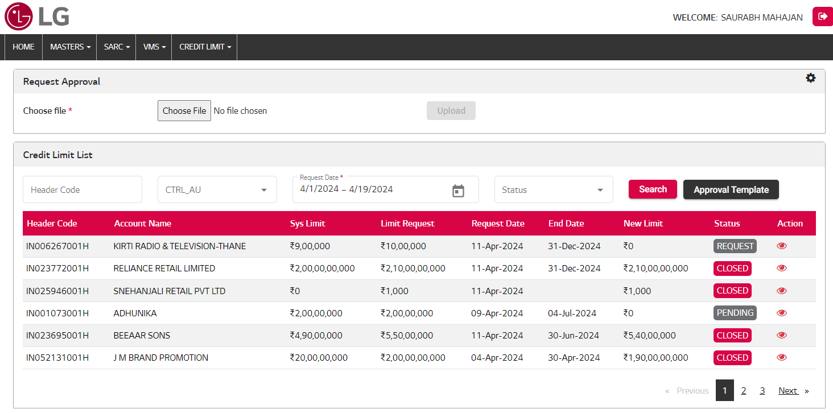

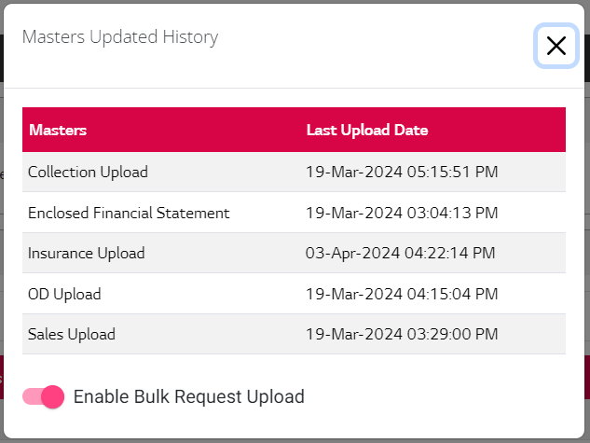

**View Credit Limit Detail**

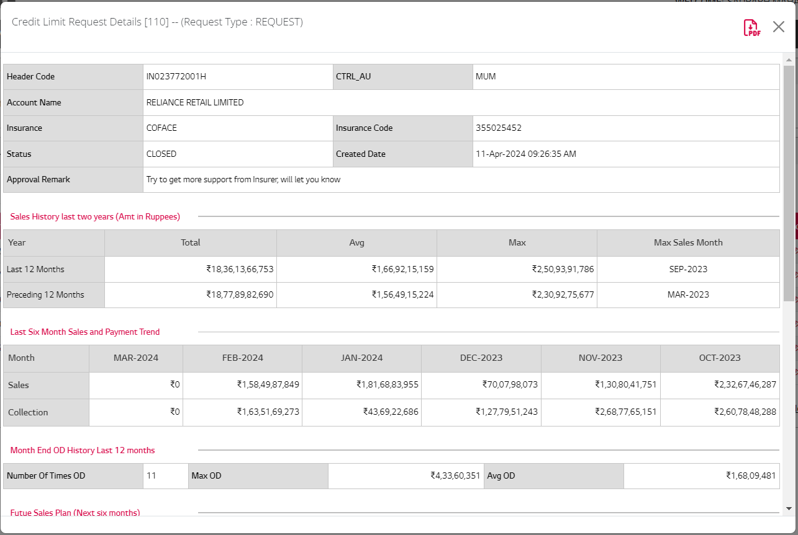

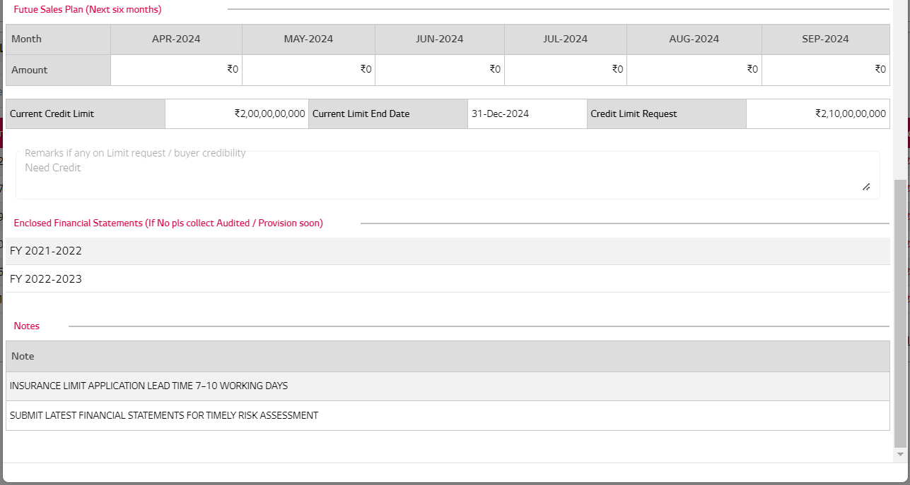

|  |  |  |
| --- | --- | --- |
| BACKEND (NEXTDNET) | | |
| Package Name | **Object Name** | **Remarks** |
| CL_CREDIT_LIMIT_PKG | REQUEST_APPROVE_INS_TMP_PROC | Request Approve Template Insert in Temp Table |
| CL_CREDIT_LIMIT_PKG | REQUEST_APPROVE_TMP_VALID_PROC | Request Approve Template Temp data Validate |
| CL_CREDIT_LIMIT_PKG | CREDIT_LIMIT_REQUEST_UPD_PROC | Credit Limit Request Detail Update in Main table |
| CL_CREDIT_LIMIT_PKG | CL_REQUEST_READ_PROC | Credit Limit Request Details Read |
| CL_CREDIT_LIMIT_PKG | MASTERS_UPLOAD_READ_PROC | Master Updated History Read |

|  |  |  |  |
| --- | --- | --- | --- |
|  |  | API | |
| SNo. | **Action** | **API Name** | **Remarks** |
| 1. | Setting Icon Action | api/UtilitiesARCreditLimit/MastersUpdatedRead | Masters Updated History Read |
| 2. | Setting Icon Action | api/LookupMaster/ReadLookup | Bulk Request Upload Status Read |
| 3. | Toggle button | api/LookupMaster/SaveLookup | Update Bulk Request Status |
| 4. | Search Button | api/ARCreditLimit/ReadAllRequest | Read credit limit requests |
| 5. | Approval Template | api/ARCreditLimit/ReadAllRequest | Approval Template download |
| 6. | Approval Template Upload | api/ARCreditLimit/RequestApproval | Credit Limit Approval Template Upload |
| 7. | Action button | api/ARCreditLimit/ReadAllRequest | Credit Limit details read |
| 8. | PDF export button | api/ARCreditLimit/RequestDownload | Credit Limit details export in PDF |

| Model Name | | CREDIT LIMIT SYSTEM | | | Table Owner | |  | |
| --- | --- | --- | --- | --- | --- | --- | --- | --- |
| Table Name | | CL_REQUEST_APPROVE_TMP_TB | | | Entity Name | |  | |
| Table Description | | Request Approve detail Temp Table | | | | | | |
| Column Name | Key | | Data Type | Length | | Nullable | Attribute Name | Default Value |
| REQ_ID |  | | NUMBER |  | | Y |  |  |
| HEADER_CODE |  | | VARCHAR2(100) |  | | Y |  |  |
| ACCOUNT_NAME |  | | VARCHAR2(500) |  | | Y |  |  |
| CTRL_AU |  | | VARCHAR2(50) |  | | Y |  |  |
| NEW_LIMIT |  | | NUMBER(18) |  | | Y |  |  |
| APPROVAL_STATUS |  | | VARCHAR2(50) |  | | Y |  |  |
| STATUS |  | | VARCHAR2(50) |  | | Y |  |  |
| REMARKS |  | | VARCHAR2(100) |  | | Y |  |  |
| ROW_NUMBER |  | | NUMBER |  | | Y |  |  |
| CREATED_BY |  | | VARCHAR2(250) |  | | Y |  |  |
| CREATION_DATE |  | | DATE |  | | Y |  | SYSDATE |
| LAST_UPDATED_BY |  | | VARCHAR2(250) |  | | Y |  |  |
| LAST_UPDATED_DATE |  | | DATE |  | | Y |  | SYSDATE |
| ATTRIBUTE1 |  | | VARCHAR2(500) |  | | Y |  |  |
| ATTRIBUTE2 |  | | VARCHAR2(500) |  | | Y |  |  |
| ATTRIBUTE3 |  | | VARCHAR2(500) |  | | Y |  |  |
| ATTRIBUTE4 |  | | VARCHAR2(500) |  | | Y |  |  |
| ATTRIBUTE5 |  | | VARCHAR2(500) |  | | Y |  |  |
| ATTRIBUTE6 |  | | NUMBER |  | | Y |  |  |
| ATTRIBUTE7 |  | | NUMBER |  | | Y |  |  |
| ATTRIBUTE8 |  | | NUMBER |  | | Y |  |  |
| ATTRIBUTE9 |  | | NUMBER |  | | Y |  |  |
| ATTRIBUTE10 |  | | DATE |  | | Y |  |  |
| ATTRIBUTE11 |  | | DATE |  | | Y |  |  |
| ATTRIBUTE12 |  | | DATE |  | | Y |  |  |
| APPROVAL_REMARK |  | | VARCHAR2(1000) |  | | Y |  |  |

| Model Name | CREDIT LIMIT SYSTEM | | | | Table Owner |  | |
| --- | --- | --- | --- | --- | --- | --- | --- |
| Table Name | CL_REQUEST_APPROVE_TMP_ERR_TB | | | | Entity Name |  | |
| Table Description | Request Approve detail Error Table | | | | | | |
| Column Name | Key | Data Type | Length | Nullable | | Attribute Name | Default Value |
| REQ_ID |  | NUMBER |  | Y | |  |  |
| HEADER_CODE |  | VARCHAR2(100) |  | Y | |  |  |
| ACCOUNT_NAME |  | VARCHAR2(500) |  | Y | |  |  |
| CTRL_AU |  | VARCHAR2(50) |  | Y | |  |  |
| NEW_LIMIT |  | NUMBER(18) |  | Y | |  |  |
| APPROVAL_STATUS |  | VARCHAR2(50) |  | Y | |  |  |
| STATUS |  | VARCHAR2(50) |  | Y | |  |  |
| REMARKS |  | VARCHAR2(1000) |  | Y | |  |  |
| ROW_NUMBER |  | NUMBER |  | Y | |  |  |
| CREATED_BY |  | VARCHAR2(250) |  | Y | |  |  |
| CREATION_DATE |  | DATE |  | Y | |  |  |
| LAST_UPDATED_BY |  | VARCHAR2(250) |  | Y | |  |  |
| LAST_UPDATED_DATE |  | DATE |  | Y | |  |  |
| ATTRIBUTE1 |  | VARCHAR2(500) |  | Y | |  |  |
| ATTRIBUTE2 |  | VARCHAR2(500) |  | Y | |  |  |
| ATTRIBUTE3 |  | VARCHAR2(500) |  | Y | |  |  |
| ATTRIBUTE4 |  | VARCHAR2(500) |  | Y | |  |  |
| ATTRIBUTE5 |  | VARCHAR2(500) |  | Y | |  |  |
| ATTRIBUTE6 |  | NUMBER |  | Y | |  |  |
| ATTRIBUTE7 |  | NUMBER |  | Y | |  |  |
| ATTRIBUTE8 |  | NUMBER |  | Y | |  |  |
| ATTRIBUTE9 |  | NUMBER |  | Y | |  |  |
| ATTRIBUTE10 |  | DATE |  | Y | |  |  |
| ATTRIBUTE11 |  | DATE |  | Y | |  |  |
| ATTRIBUTE12 |  | DATE |  | Y | |  |  |
| APPROVAL_REMARK |  | VARCHAR2(1000) |  | Y | |  |  |

### Backend Process

### Jobs (NEXTDNET)

|  |  |  |  |
| --- | --- | --- | --- |
| JOB | What | Interval | Remarks |
|  | CL_EMAIL_PKG.EMAIL_CL_REQUEST_SUMMARY_PROC | Every 6 hours | New Credit Limit Request Summery auto email send. |
|  | CL_EMAIL_PKG. EMAIL_CL_PENDING_SUMMARY_PROC | Every 6 hours | Pending Credit Limit Request Summery auto email send. |
|  | CL_EMAIL_PKG. EMAIL_CL_CLOSED_SUMMARY_PROC | Every 6 hours | Closed Credit Limit Request Summery auto email send. |
|  | CL_EMAIL_PKG. EMAIL_CL_REQUEST_PROC | Every 30 Minutes | New Request Credit Limit of PDF file send on Email. |
|  | CL_EMAIL_PKG. EMAIL_CL_CLOSED_PROC | Every 30 Minutes | Closed Request of Credit Limit PDF file send on Email. |

**THANK YOU**